Supplementary Information
Investigating the dispersal of macro- and microplastics on agricultural fields 30 years after sewage sludge application
Collin J. Weber, Alexander Santowski and Peter Chifflard
Correspond to: Collin J. Weber (collin.weber@geo.uni-marburg.de)

License: CC BY 4.0 International - Creative Commons, Attribution
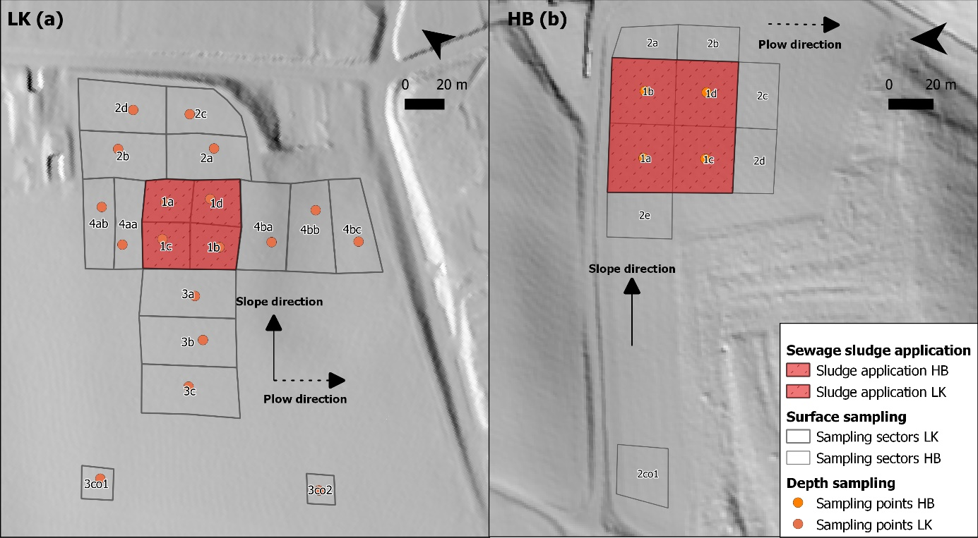
Supplementary Figure S1. Overview of sampling sectors for surface sampling and sampling point for depth sampling on agricultural fields (a) “Lehmkaute” (LK) and (b) “Holzbach” (HB) based on digital terrain model (© Hessian State Office for Land Management and Geoinformation, 2019) with slope and hang parallel plow directions.

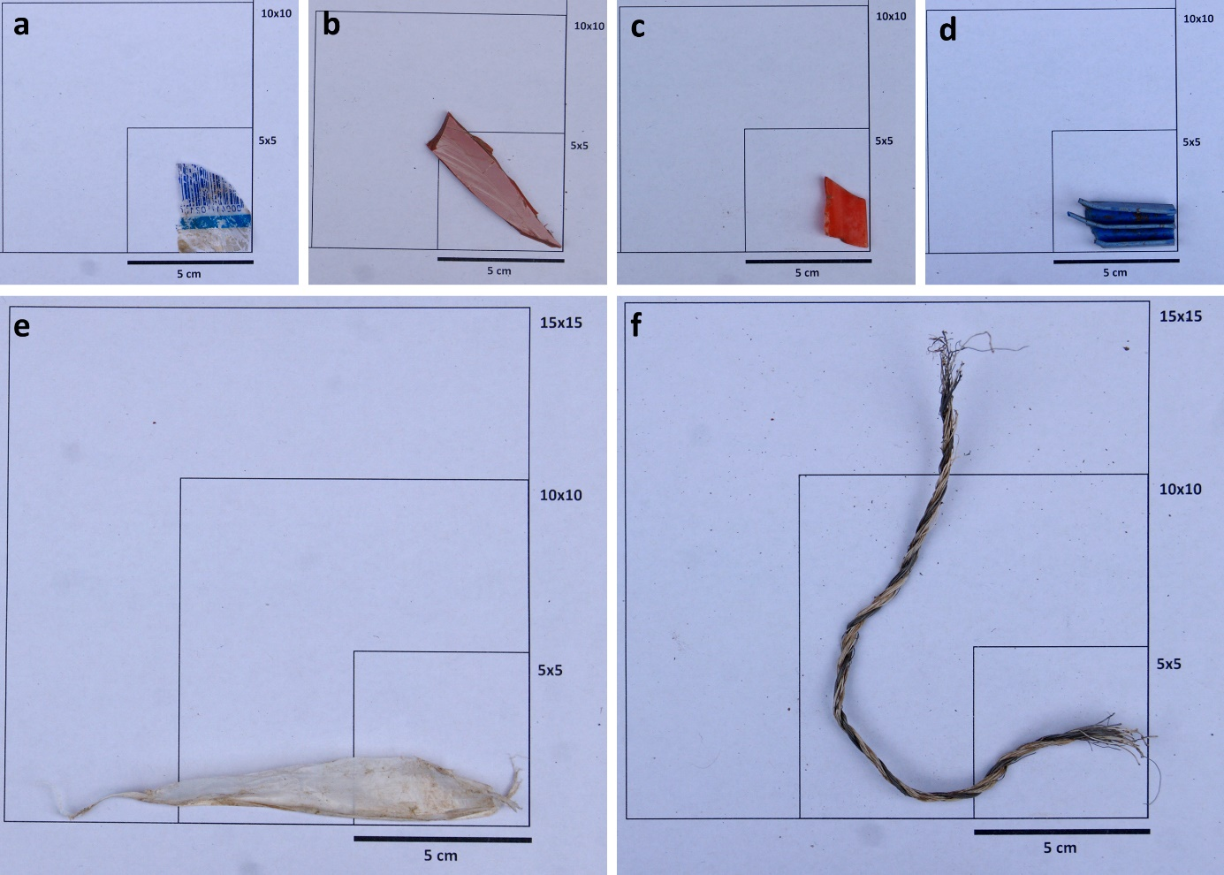
Supplementary Figure S2. Examples of collected plastic items on soil surfaces from field “Lehmkaute”showing (a) blue and white packaging residue made of polypropylene (PP), (b) red fragment made of polyvinyl chloride (PVC), (c) red fragment made of high-density polyethylene (HDPE), (d) blue fragment made of polypropylene (PP), (e) transparent film made of polyethylene terephthalate (PET) and (f) cable tie made of polyester fibres.

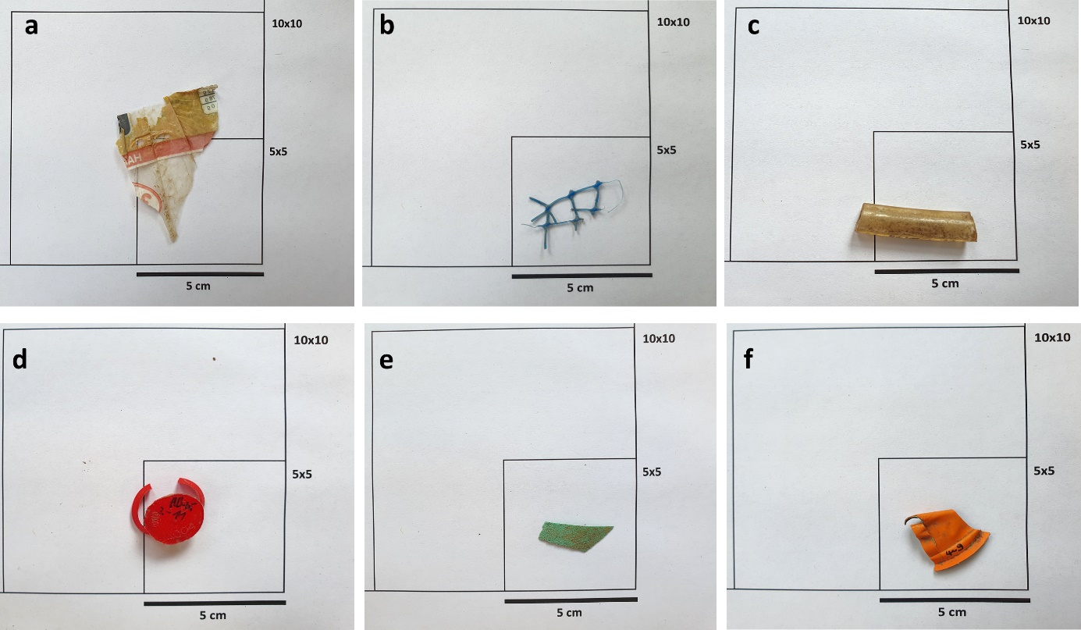
Supplementary Figure S3. Examples of collected plastic items on soil surfaces from field “Lehmkaute” showing (a) colored packaging residue made of polypropylene (PP), (b) blue net made of light-density polyethylene (LDPE), (c) cable fragment made of polyvinyl chloride (PVC), (d) red closure fragment made of light-density polyethylene (LDPE), (e) green fragment made of light-density polyethylene (LDPE) and (f) orange fragment made of polystyrene (PS).

Supplementary Table S1: Sewage sludge, management practice since 2016 and sampling area information.
 | LK ("Lehmkaute") | HB ("Holzbach")
Sludge type | Sewage sludge (yearly) and waste sewage sludge compost (3-year interval) with 22.8 % foreign matter (1981) | Sewage sludge (3-year interval) without data about foreign matter content
Sludge origin | Composting plant Bad Kreuznach (Rhineland-Palatinate) | Cappel wastewater treatment plant (Marburg, Hesse, Germany)
Agricultural crops | Beets (2016), Wheat (2017), Corn (2018), Wheat (2019), Beets (2020) | Rape (2016), Wheat (2017), Field grass (2018), Fallow (2019), Wheat (2020)
Organic fertilization | 89 m³ ha digestate in 2016, 2017 and 2020 | 45 m³ ha digestate in 2017 and 2020
Further fertilizer applications | Mineral and mixed fertilizers (yearly), crop protection products | Mineral and mixed fertilizers (yearly), crop protection products
Sludge application duration | 1973-1986 | 1969-1986
Sludge application rate | 120–200 t ha (3 year interval) | 2.5–5 t ha (3 year interval)
Sludge application area (m²) | 2313.2 | 3477.2
Total field area (ha) | 5.69 | 1.71
Investigated area (ha) | 1.51 | 0.67
Number of sectors (drill cores) | 18 (18) | 10 (4)
Average sector size (m²) | 837.13 | 667.89

Supplementary Table S2: Weather conditions in the surroundings of the study area for the period 1986-2021 (after sewage sludge application)
 | Period 1986-2021
 | Min | Average | Max
Annual average temperature (°C) | 7.6 | 9.7 | 10.8
Annual temperature deviation (°C) | -2.1 | -0.1 | 1.1
Precipitation annual sum (mm) | 543.0 | 678.5 | 873.7
Days with snow cover (>1 cm) | 0.0 | 17.7 | 58.0
Frost days | 51.0 | 78.4 | 117.0
Data source: Cölbe weather station (ID: DWD 3164) 50.8489°N, 8.7733°E. Distance from the study area: 12 km (Data obtained through: https://www.hlnug.de/messwerte/witterungs-und-klimadaten/wetterextreme)

Supplementary Table S3: Wind conditions in the surroundings of the study area for the period 1986-2021 showing 10 years interval (after sewage sludge application)

Year | Average annual wind speed (km h⁻¹) | Average maximal gust speed (km h⁻¹)
1986 | 9.67 | 72.00
1996 | 8.58 | 61.42
2006 | 11.33 | 67.67
2016 | 11.08 | 65.08
2020 | 11.67 | 65.75
Data source: Gießen weather station (ID: DWD 1639) 50.6014°N, 8.6439°E. Distance from the study area: 20 km (Data obtained through: https://www.hlnug.de/messwerte/witterungs-und-klimadaten/wetterextreme)

