Supplementary data for manuscript

Revealing the solid-state processing mechanisms of Antiferroelectric AgNbO₃ for energy storage

Mao-Hua Zhang¹, Leif Carstensen², Changhao Zhao¹, Lovro Fulanović¹, Wolfgang Donner² and Jurij Koruza^{1,*}

¹Nonmetallic Inorganic Materials, Department of Materials and Earth Sciences, Technical University of Darmstadt, Darmstadt, Germany
²Structure Research, Department of Materials and Earth Sciences, Technical University of Darmstadt, Darmstadt, Germany

* Corresponding author: koruza@ceramics.tu-darmstadt.de

Figure S1. X-ray diffraction pattern of stoichiometric AgO/Nb₂O₅ mixture before milling. The set of tick marks represents the reflections associated with the structures of Nb₂O₅ and AgO (for labels, please refer to the PDF-ICDD database, 2011). All reflections are identified as either AgO or Nb₂O₅

Figure S2. Photo of stoichiometric AgO/Nb₂O₅ powder mixture before (left) and after (right) ball milling. The mixture on the left was hand-mixed using a spatula.

Figure S3. Particle size distribution of the stoichiometric powder mixture after homogenization milling in ethanol (16 h at 250 rpm), prior to calcination. The measurement was carried out using a laser granulometer (Saturn DigiSizer 5200, Micromeritics, USA ). The powder mixture consisted of AgO and Nb₂O₅ before milling and transformed into a mixture of metallic Ag and Nb₂O₅ after high-energy milling.

Figure S4. Evolved gas analysis (EGA) of the ball milled nominal AgO/Nb₂O₅ powder mixture (actual composition Ag/Nb₂O₅) as a function of temperature. The analysis was performed using Fourier Transform Infrared Spectrometer (Bruker Tensor 27, Mid-infrared range with gas cell, Bruker Optics, Gemany). Gases evolved during the mass loss around 200 °C were acetic acid (C₂H₄O₂), carbon dioxide (CO₂), and carbon monoxide (CO), which point towards a reaction of ethanol with oxygen, which was catalyzed by the presence of metallic Ag.

Figure S5. In situ XRD of the unmilled stoichiometric mixture as a function of temperature from room temperature (RT) to 600 °C. The set of tick marks represents the reflections associated with the structures of AgO, Nb₂O₅, AgNbO₃, and Ag (for labels, please refer to the PDF-ICDD database, 2011). Unlike for the milled powder, large amounts of unreacted Ag and Nb₂O₅ were observed even at 600 °C.

Figure S6. Scanning electron microscopy (SEM) imaging of the thermally etched AgNbO₃ samples.

Figure S7. Optical microscopy imaging of the polished AgNbO₃ samples, examined in the reflected polarized light microscopy mode using the Axio Imager 2 microscope (Zeiss, Germany). Black arrows indicate the presence of inclusions, which are present in all four samples.

Figure S8. Back-scattered electron (BSE) imaging of the polished AgNbO₃ samples. Black arrows indicate inclusions, the composition of which was examined using energy dispersive X ray (EDX) spectroscopy in the scanning electron microscope (XL 30 FEG, Philips, Eindhoven, Netherlands). The EDX results show that these inclusions are Ag-rich, as shown in Figure S9.

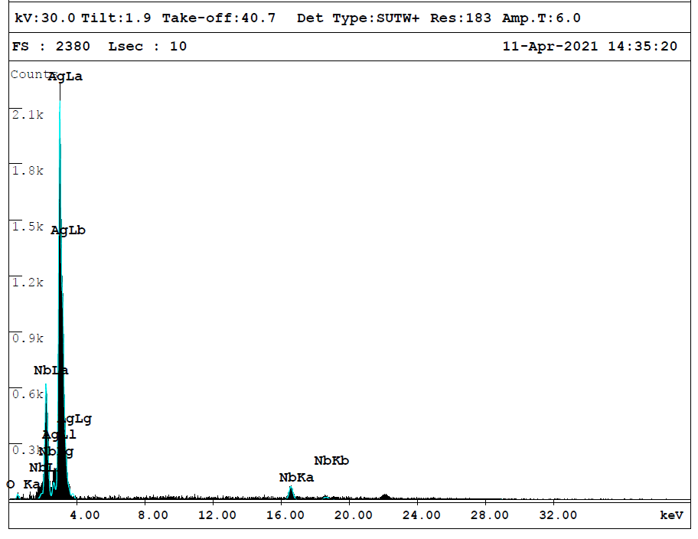
Figure S9. Energy dispersive X-ray (EDX) point analysis of the inclusions of AgNbO₃ samples, showing the inclusions are Ag-rich.

Figure S10. AgNbO₃ pellets processed in N₂ atmosphere (3 h at 1080 °C). The pellet diameter is about 9 mm. The silver oxide is reduced, while the formation of AgNbO₃ is prevented, which results in the formation of droplets of metallic silver at sample´s surface.

Figure 11. X-ray diffraction pattern of ball milled AgO/Nb₂O₅ powder mixture after calcination in N₂ at 850 °C and 6 h. The measurement was performed on an X-ray diffractometer with Bragg-Brentano geometry (XRD, Bruker AXS D8 Advance, Germany) with Cu Kα radiation. The set of tick marks represents the reflections associated with the structures of Ag, Nb₂O₅, and AgO. All reflections are identified as either Ag or Nb₂O₅, i.e., no formation of perovskite AgNbO₃ was observed in N₂ atmosphere.

Figure S12. (a) Polarization and (b) strain hysteresis loops of AgNbO₃ samples under an electric field of 14 kV/mm (1st cycle, measured at 1 Hz).

