Supplemental material:
Influence of Zn²⁺ doping on the morphotropic phase boundary in lead-free piezoelectric (1-x)Na_{1/2}Bi_{1/2}TiO₃-xBaTiO₃
Daniel Bremecker*, K. V. Lalitha, Siegfried Teuber, Jurij Koruza, Jürgen Rödel
Division of Nonmetallic-Inorganic Materials, Department of Materials and Earth Sciences, Technical University of Darmstadt, 64287 Darmstadt, Germany
*E-Mail: bremecker@ceramics.tu-darmstadt.de

Supplemental material
Table S 1: Average grain size and variance of NBT-xBT and NBT-xBT-0.5 Zn samples.
 | -5BT | -5.5BT | -6BT | -6.5BT | -7BT | -5BT-0.5 Zn | -5.5BT-0.5 Zn | -6BT-0.5 Zn | -6.5BT-0.5 Zn | -7BT-0.5 Zn
Grain size (μm) | 2.1 | 1.4 | 1.7 | 1.2 | 1.2 | 14.7 | 15.6 | 9.4 | 14.1 | 13.8
Variance (μm) | 2 | 0.8 | 0.8 | 0.7 | 0.7 | 5.5 | 6.6 | 4.4 | 6.5 | 5.9

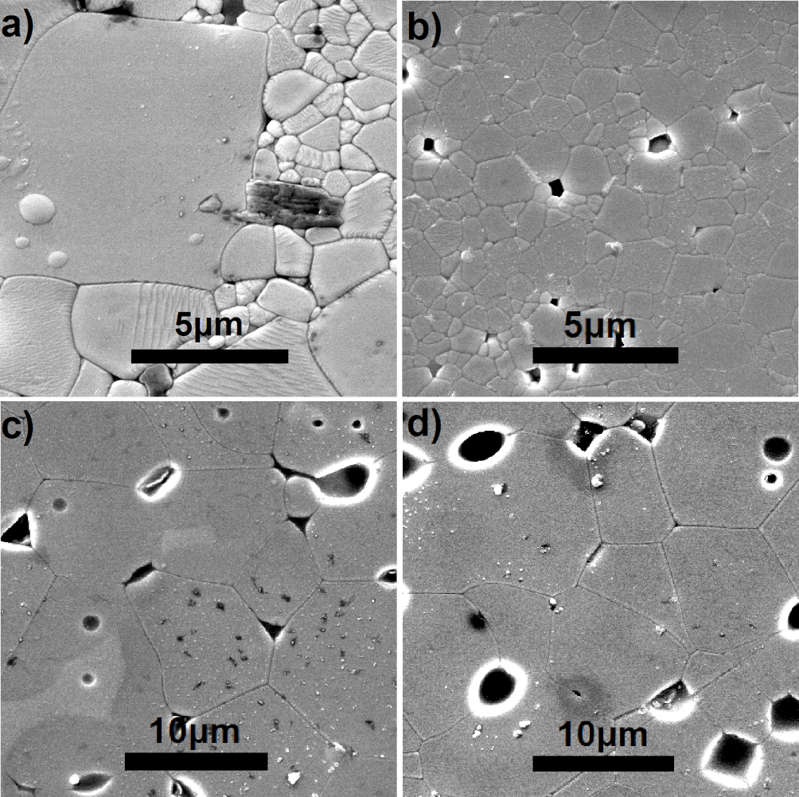
Figure S 1: Microstructures of the ground, polished and thermally-etched NBT-5BT (a), NBT-7BT (b), NBT-5BT-0.5 Zn (c) and NBT-7BT-0.5 Zn (d) samples.

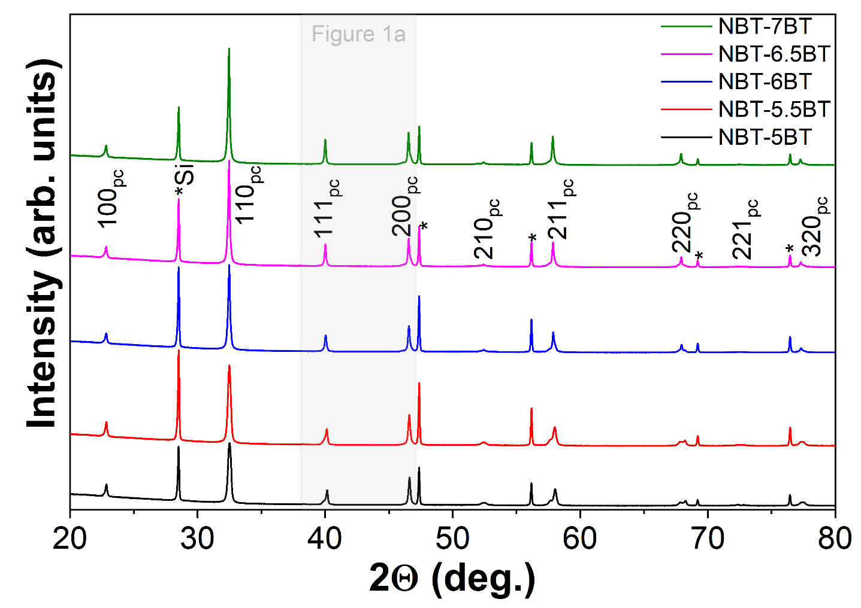
Figure S 2: X-ray diffraction profiles of (1-x)NBT-xBT with x=0.05, 0.055, 0.06, 0.065, 0.07. The NBT-BT powders were mixed with a silicon standard to get the instrumental parameters (Si peaks are marked with *).
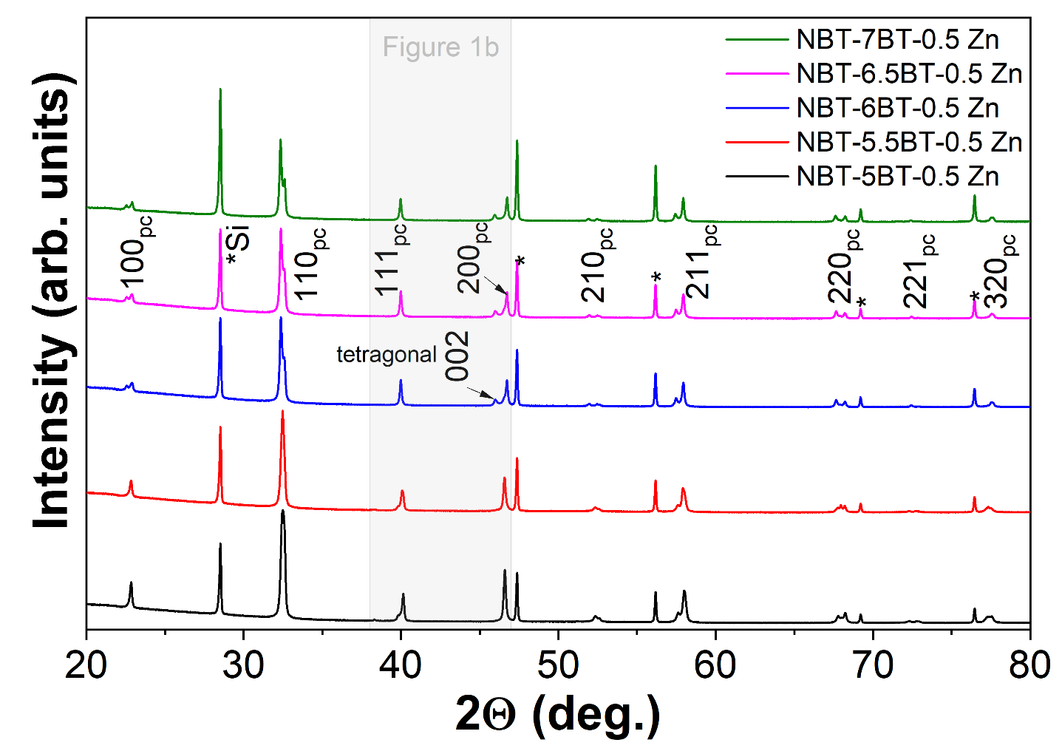
Figure S 3: X-ray diffraction profiles of (1-x)NBT-xBT-0.5 mol % Zn with x=0.05, 0.055, 0.06, 0.065, 0.07. An internal silicon standard was measured to get the instrumental parameters (Si peaks are marked with *).

Table S 2: Detailed refinement data.
 | R3c |  | $$Pm\overline{3}m$$ | P4mm |  | Reliability factors
NBT-5BT | a= 5.4999 (Å) c= 13.5773 (Å)  V= 59.28 |  | a= 3.9003 (Å)  V= 59.34 |  |  | Rp: 2.36 Rwp: 3.25 Rexp: 1.65
NBT-5.5BT | a= 5.5033 (Å) c= 13.5739 (Å) V= 59.34 |  | a= 3.9031 (Å)  V= 59.46 |  |  | Rp: 3.08 Rwp: 5.24 Rexp: 1.54
NBT-6BT | a= 5.5023 (Å) c= 13.5939 (Å) V= 59.40 |  | a= 3.9038 (Å)  V= 59.49 | a= 3.8922 (Å) c= 3.9378 (Å) V= 59.65 |  | Rp: 2.19 Rwp: 3.11 Rexp: 1.60
Site x y z  Na 0.00000 0.00000 0.27582  Bi 0.00000 0.00000 0.27582  Ba 0.00000 0.00000 0.27582  Ti 0.00000 0.00000 0.02083  O 0.08893 0.35931 0.08330 |  | Site x y z  Na 0.00000 0.00000 0.00000  Bi 0.00000 0.00000 0.00000  Ba 0.00000 0.00000 0.00000  Ti 0.50000 0.50000 0.50000  O 0.50000 0.50000 0.00000 |  |  | Site x y z  Bi 0.00000 0.00000 0.00000  Ba 0.00000 0.00000 0.00000  Na 0.00000 0.00000 0.00000  Ti 0.50000 0.50000 0.45432  O 0.50000 0.50000 -0.15000  O 0.50000 0.00000 0.40000
NBT-6.5BT |  |  | a= 3.9053 (Å)  V= 59.56 | a= 3.8932 (Å) c= 3.9339 (Å) V= 59.63 |  | Rp: 2.29 Rwp: 3.23 Rexp: 1.57
NBT-7BT |  |  | a= 3.9058 (Å)  V= 59.59 | a= 3.8947 (Å) c= 3.9350 (Å) V= 59.69 |  | Rp: 2.31 Rwp: 3.50 Rexp: 1.61
NBT-5BT  -0.5 Zn | a= 5.5013 (Å) c= 13.5908 (Å) V= 59.37 |  | a= 3.8998 (Å)  V= 59.31 |  |  | Rp: 2.47 Rwp: 3.76 Rexp: 1.59
NBT-5.5BT  -0.5 Zn | a= 5.5023 (Å) c= 13.5987 (Å) V= 59.43 |  | a= 3.9023 (Å)  V= 59.43 | a= 3.8907 (Å) c= 3.9385 (Å) V= 59.62 |  | Rp: 2.21 Rwp: 3.22 Rexp: 1.64
NBT-6BT  -0.5 Zn | a= 5.5043 (Å) c= 13.5989 (Å) V= 59.47 |  | a= 3.9048 (Å)  V= 59.54 | a= 3.8895 (Å) c= 3.9467 (Å) V= 59.71 |  | Rp: 2.08 Rwp: 3.09 Rexp: 1.63
NBT-6.5BT  -0.5 Zn |  |  | a= 3.9051 (Å)  V= 59.55 | a= 3.8903 (Å) c= 3.9475 (Å) V= 59.75 |  | Rp: 1.87 Rwp: 2.79 Rexp: 1.64
NBT-7BT  -0.5 Zn |  |  | a= 3.9062 (Å)  V= 59.6 | a= 3.8899 (Å) c= 3.9520 (Å) V= 59.8 |  | Rp: 2.63 Rwp: 4.49 Rexp: 1.72

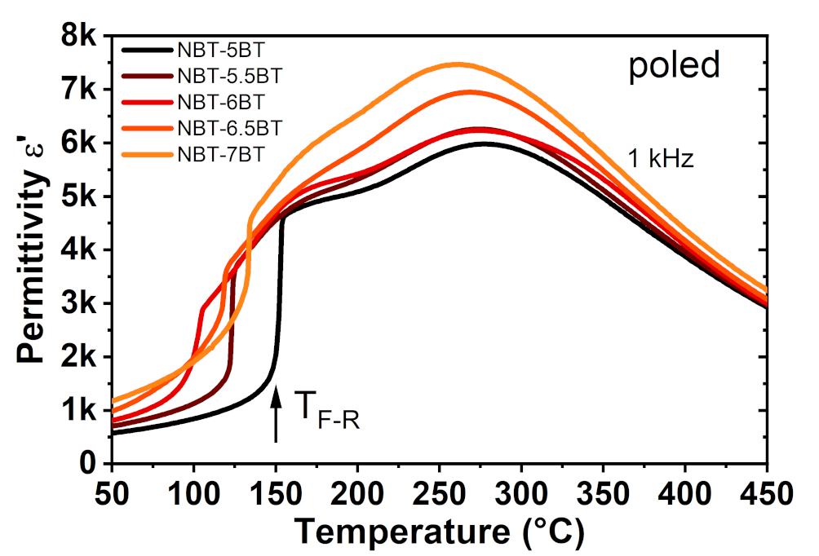
Figure S 4: Permittivity vs. temperature at 1 kHz AC-field from NBT-5BT to NBT-7BT. All samples are measured in poled state to evaluate T_{F-R}.

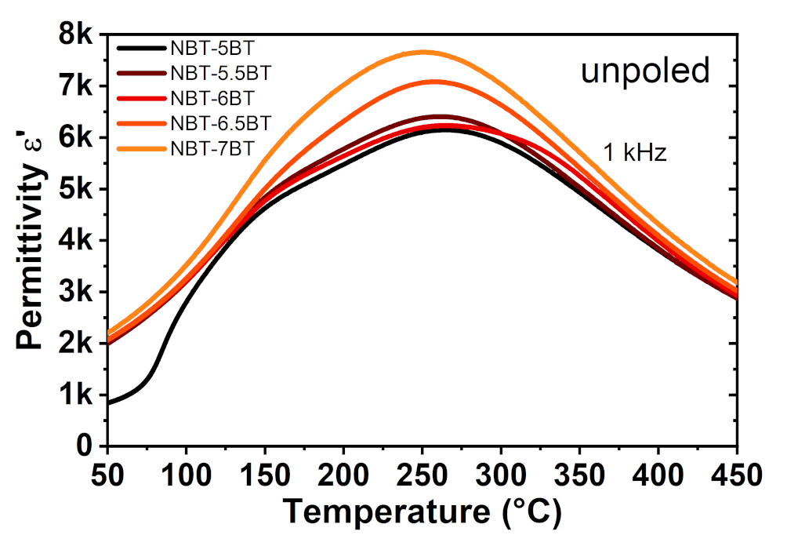
Figure S 5: Permittivity vs. temperature at 1 kHz AC-field from NBT-5BT to NBT-7BT. All samples are measured in unpoled state.

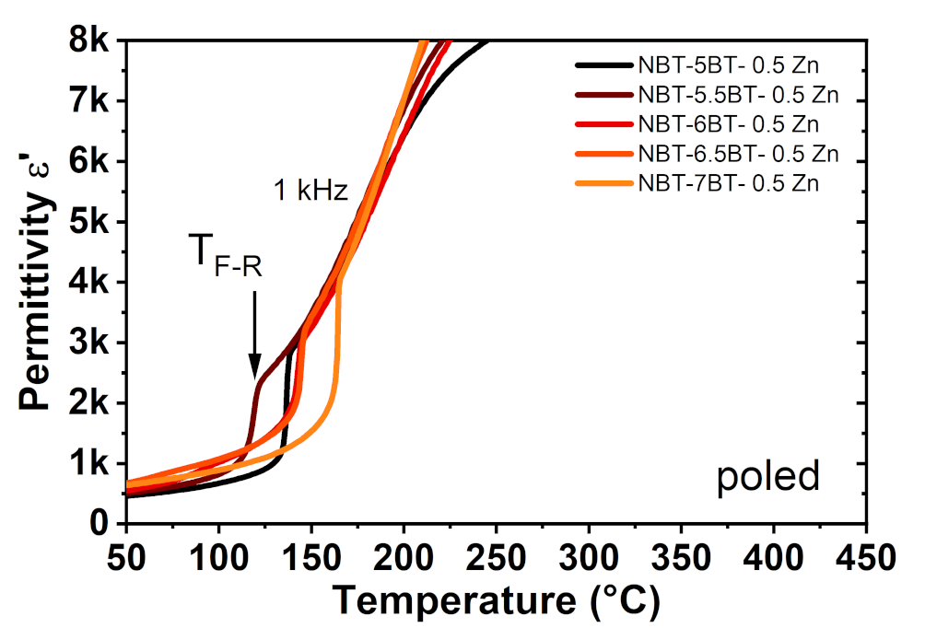
Figure S 6: Permittivity vs. temperature at 1 kHz AC-field from NBT-5BT-0.5 Zn to NBT-7BT-0.5 Zn. All samples are measured in poled state to evaluate T_{F-R}.

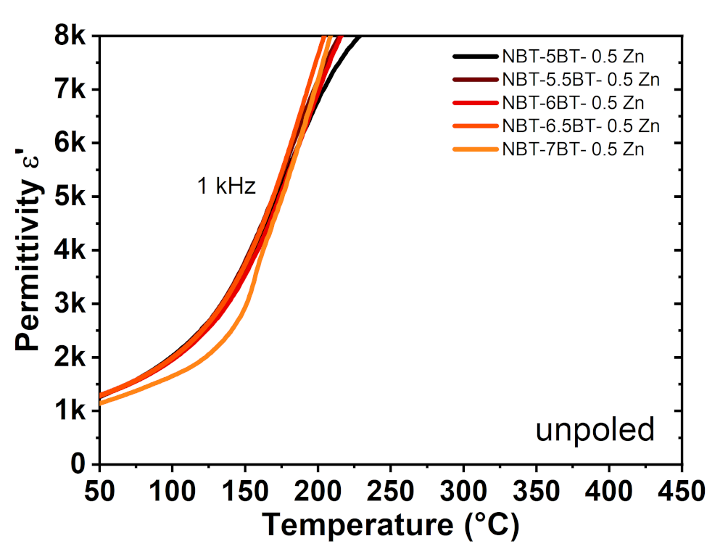
Figure S 7: Permittivity vs. temperature at 1 kHz AC-field from NBT-5BT-0.5 Zn to NBT-7BT-0.5 Zn. All samples are measured in unpoled state.

