Appendix A: Implementation dates of containment measures
Table A1: Implementation dates of containment measures at federal state level
Federal state | # NUTS-3 districts | School closure | Establishment closure | Shopping mall closure | Restaurant closure | Contact restrictions | Face mask duty
Baden-Wurttemberg | 44 | 17.03. | 17.03. | 18.03. | 21.03. | 23.03. | 27.04.
Bavaria | 96 | 16.03. | 17.03. | 18.03. | 21.03. | 21.03. | 27.04.
Berlin | 1 | 17.03. | 15.03. | 23.03. | 22.03. | 23.03. | 27.04.
Brandenburg | 18 | 18.03. | 18.03. | 18.03. | 23.03. | 23.03. | 27.04.
Bremen | 2 | 16.03. | 18.03. | 18.03. | 21.03. | 23.03. | 27.04.
Hamburg | 1 | 16.03. | 16.03. | 17.03. | 21.03. | 23.03. | 27.04.
Hesse | 26 | 16.03. | 18.03. | 18.03. | 21.03. | 23.03. | 27.04.
Lower Saxony | 45 | 16.03. | 17.03. | 17.03. | 20.03. | 23.03. | 27.04.
Mecklenburg-W. Pom. | 8 | 16.03. | 18.03. | 18.03. | 21.03. | 23.03. | 27.04.
North Rhine-Westph. | 53 | 16.03. | 16.03. | 18.03. | 23.03. | 23.03. | 27.04.
Rhineland-Palatinate | 36 | 16.03. | 18.03. | 18.03. | 21.03. | 24.03. | 27.04.
Saarland | 6 | 18.03. | 18.03. | 18.03. | 21.03. | 21.03. | 27.04.
Saxony | 13 | 18.03. | 19.03. | 19.03. | 21.03. | 23.03. | 20.04.
Saxony-Anhalt | 14 | 16.03. | 18.03. | 18.03. | 25.03. | 23.03. | 22.04.
Schleswig-Holstein | 15 | 15.03. | 16.03. | 18.03. | 18.03. | 23.03. | 29.04.
Thuringia | 23 | 18.03. | 17.03. | 20.03. | 20.03. | 25.03. | 24.04.
Note: There are 16 federal states (NUTS-1 regions) in Germany. The federal states are sub-divided into 401 NUTS-3 districts. In most cases, the containment measures were put in place at the federal state level. If this is the case, the measure is binding for all NUTS-3 districts within the corresponding federal state. We did our best to check for different implementation dates in specific NUTS-3 districts. If we found differences, we account for them and state them in the main text.

Appendix B: Day of Diagnosis and Day of Reporting
German authorities (RKI, 2020a) measure the number of reported infections by day of reporting and by day of first appearance of symptoms. Both ways of reporting have their advantages and disadvantages. Data by date of reporting is cyclical over the week. Incidences systematically fall over the weekend and are highest around the mid of the week. At weekends, testing is reduced and local health authorities are usually closed (RKI, 2020b). As reporting does not relate one-to-one to the spread of infections, employing reporting data introduces additional measurement uncertainty. This would suggest working with incidence data by day of diagnosis.
However, data by day of diagnosis has disadvantages as well. Not all cases reported to the RKI come with the date of diagnosis. In many cases, we only know the day of reporting. As the figures show, more than one fourth of the data of the data is still by day of reporting. For these cases, knowledge on the day of first appearance of symptoms is missing. The share the data provided by day of reporting seems to increase over time.
There is one great advantage of using data by day of diagnosis. The median delay between infection and appearance of symptoms is 5.2 days with 95% lying between 2 and 12 days (Linton et al., 2020 and Lauer et al., 2020). When we are interested in the effect of some containment measure on the number of infections and use data by day of diagnosis, we would expect that the about 50% of the effect is visible five days after the measure was implemented. When we use data by day of reporting, we need an additional delay of 5 to 6 days for the patient to visit a doctor and the reporting procedure to reach this threshold. This enters further imprecision in measurement.
We therefore need to choose between a dataset that may be more precise but is not homogenous (day of first symptoms) and a dataset where we need to add additional days for reporting. In order to employ the comprehensive RKI dataset, we relate infection cases to the day of reporting. With a delay of 7 days between infection and reporting, about 25% of infection cases are expected to be statistically visible. As in related work (e.g. Mitze & Kosfeld, 2021) we capture cyclicality over the week by the day of the week effect.

Appendix C: Day of the Week Effect
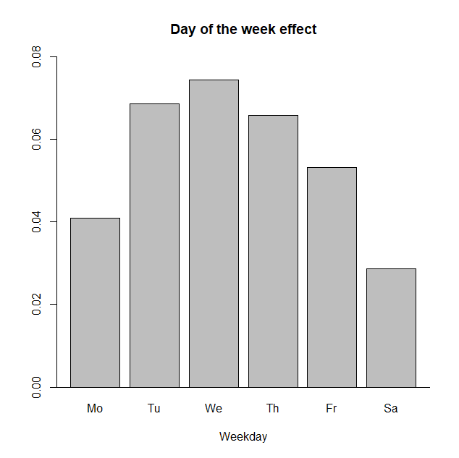
Figure C1: Day of the week effect
Figure C1 exhibits the pattern of the day of the week effect with Sunday as the reference day. Particularly because of limited testing on weekends, figures begin to rise at the start of the week. The highest growth of incidence rates of additional 7 ½ percentage points is observed on Wednesday. Growth rates are almost as high on Tuesday and Thursday. The low weekend effect is also clearly visible for Saturday. All weekday impacts are highly significant.

