## Supplementary

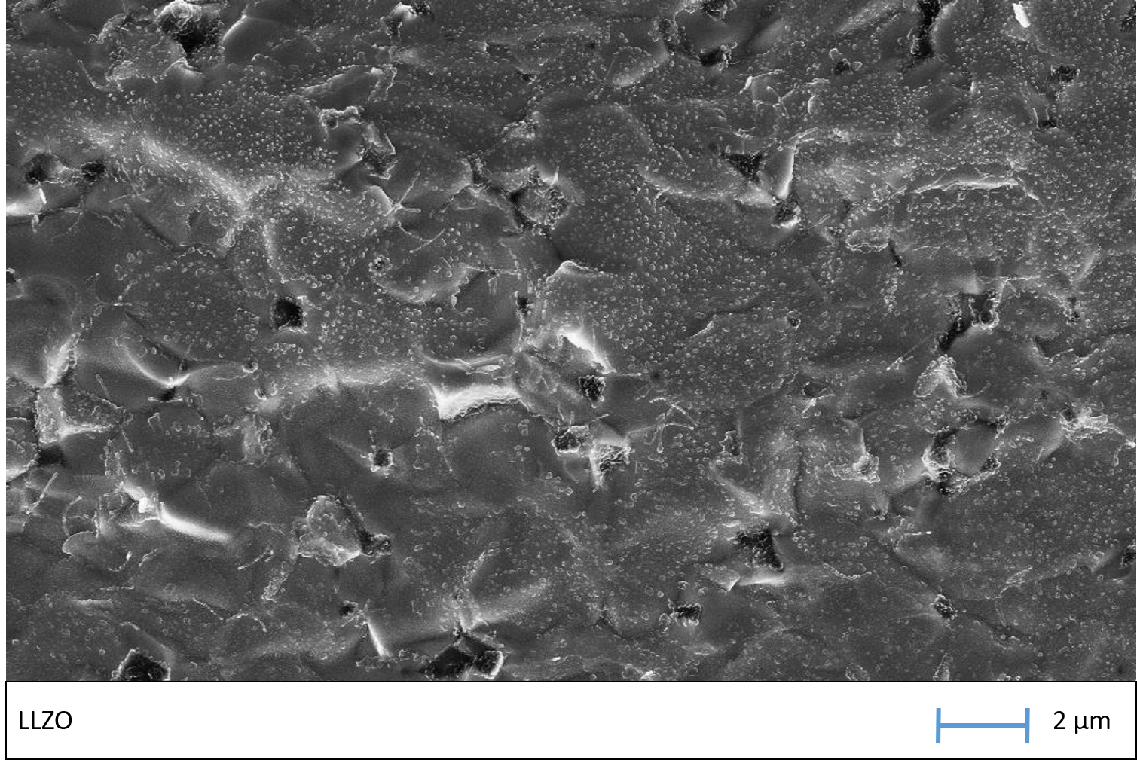

**Figure S.2:** SEM micrograph of a cross-section through a sintered LLZO pellet. As the measurement setup is not protected with an inert atmosphere, the surface of the LLZO reacts with moisture and carbon to Li2CO3. This leads to the white dots. Nevertheless, the SEM image reveals a good densification.

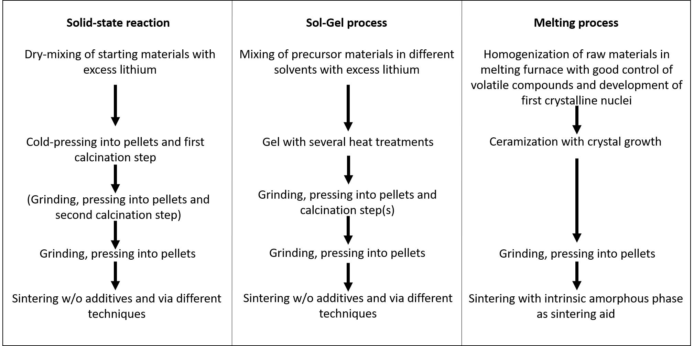

**Figure S.1:** Schematic comparison of the well-established solid-state reaction and sol-gel processes from literature with the glass-ceramic route. All processes are simplified and steps may vary in particular cases. The main advantages of the glass-ceramic route are the good homogenization of the starting materials without the need of solvents, the prevention of lithium-losses (e.g. the other methods need calcination steps) and reduction of energy-intensive grinding steps. Furthermore, there is no need for glass-forming additives during the sintering as the glass-ceramic powder already contains a controllable amount of intrinsic amorphous phase.