Supporting Information

Application of Non-precious Bifunctional Catalysts for Metal-Air Batteries

Steffen Haller, Vladislav Gridin, Kathrin Hofmann, Robert W. Stark, Barbara Albert, Ulrike I. Kramm

Calculation of the H₂O₂ yield and the electron transfer number n_{app} was conducted based on the measured disc current j_{disc} and ring current j_{ring} using the following formula:^{[1]}
 | $$n=100\frac{4 j_{disc} N_{ring}}{j_{disc} N_{ring}+j_{ring}}$$ | (S1)
and
 | $$S_{H2O2}\left(\%\right)=100\frac{2 j_{ring}}{j_{disc} N_{ring}+j_{ring}}=100\frac{4-n}{2}$$ | (S2)

with the collection efficiency of the ring N_{ring} = 0.38.

From the obtained slopes m in the KL plots, n_{KL} was calculated by the following formula:^{[2]}
 | $$n={\left[0.62 m F{D_{O}}^{\frac{2}{3}}{ ν}^{-\frac{1}{6}} c_{O}^{0}\right] }^{-1}$$ | (S3)

with F = 96485 C mol^{–1}, D₀ = 1.9∙10^{–5} cm² s^{–1}, ν = 0.01 cm² s^{–1} and c_{O}⁰ = 1.2∙10^{–6} mol cm^{–3}.

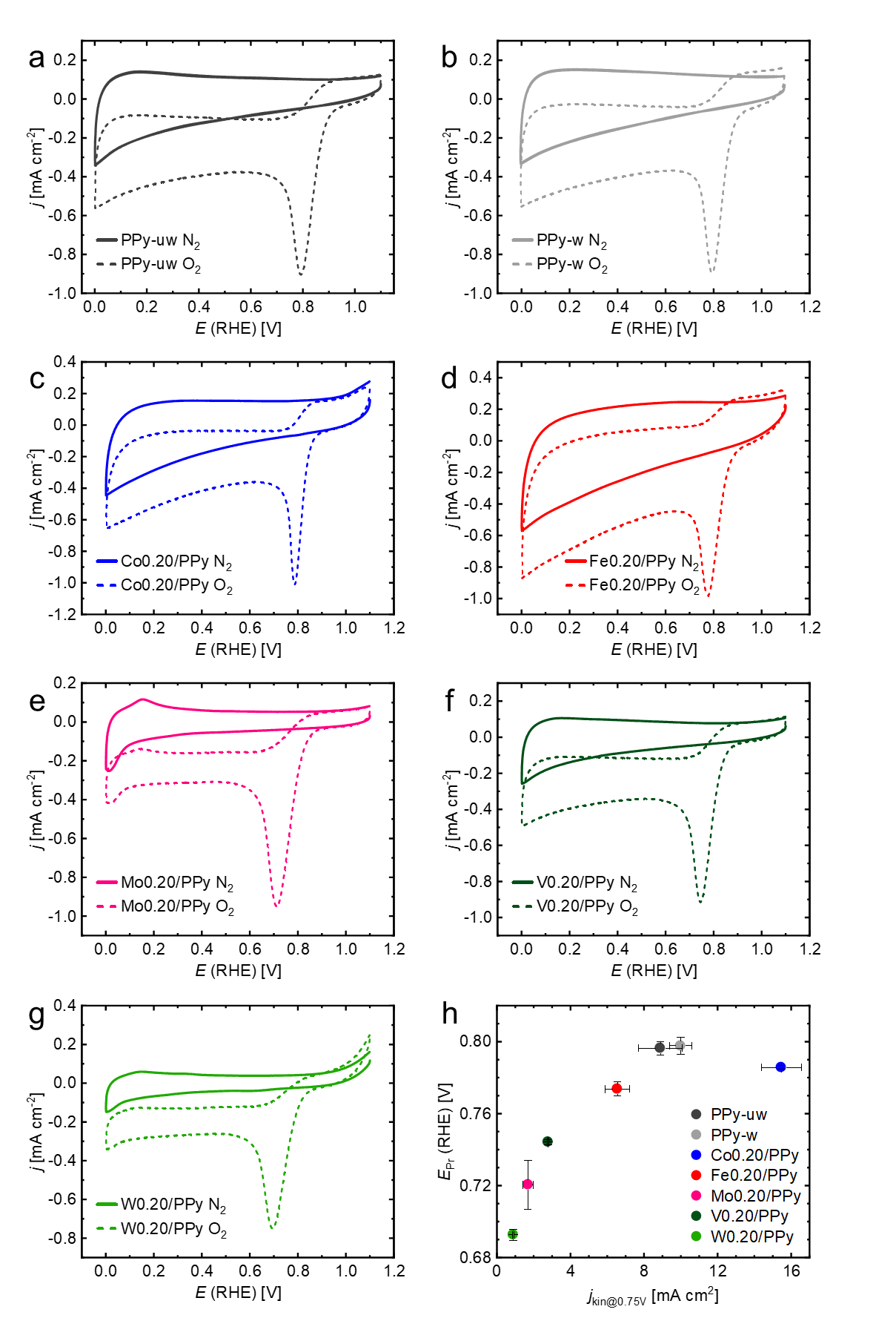
Figure S1: Cyclic voltammograms in N₂- and O₂-saturated electrolyte, recorded at scan rates of 10 mV s^{–1}: (a) PPy-uw, (b) PPy-w, (c) Co0.20/PPy, (d) Fe0.20/PPy, (e) Mo0.20/PPy, (f) V0.20/PPy, (g) W0.20/PPy, (h) peak reduction potentials E_{Pr} plotted against kinetic current densities at 0.75 V.
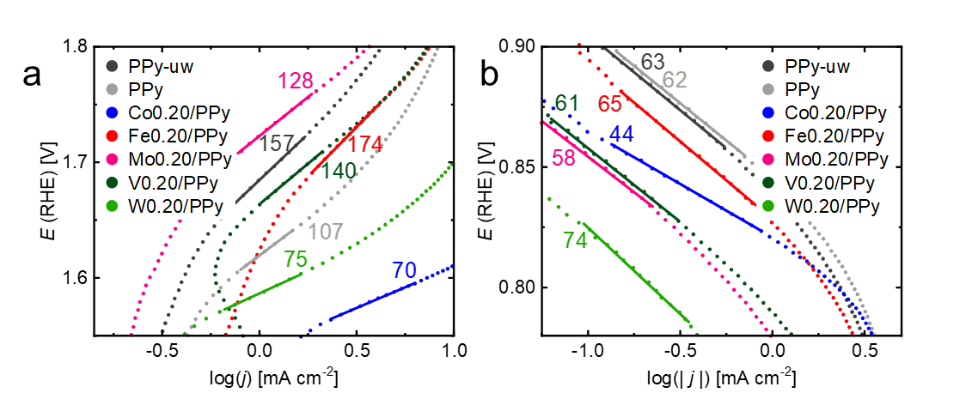
Figure S2: Transition metal variation series: (a) OER Tafel plots, (b) ORR Tafel plots, with Tafel slopes in mV dec^{–1}.

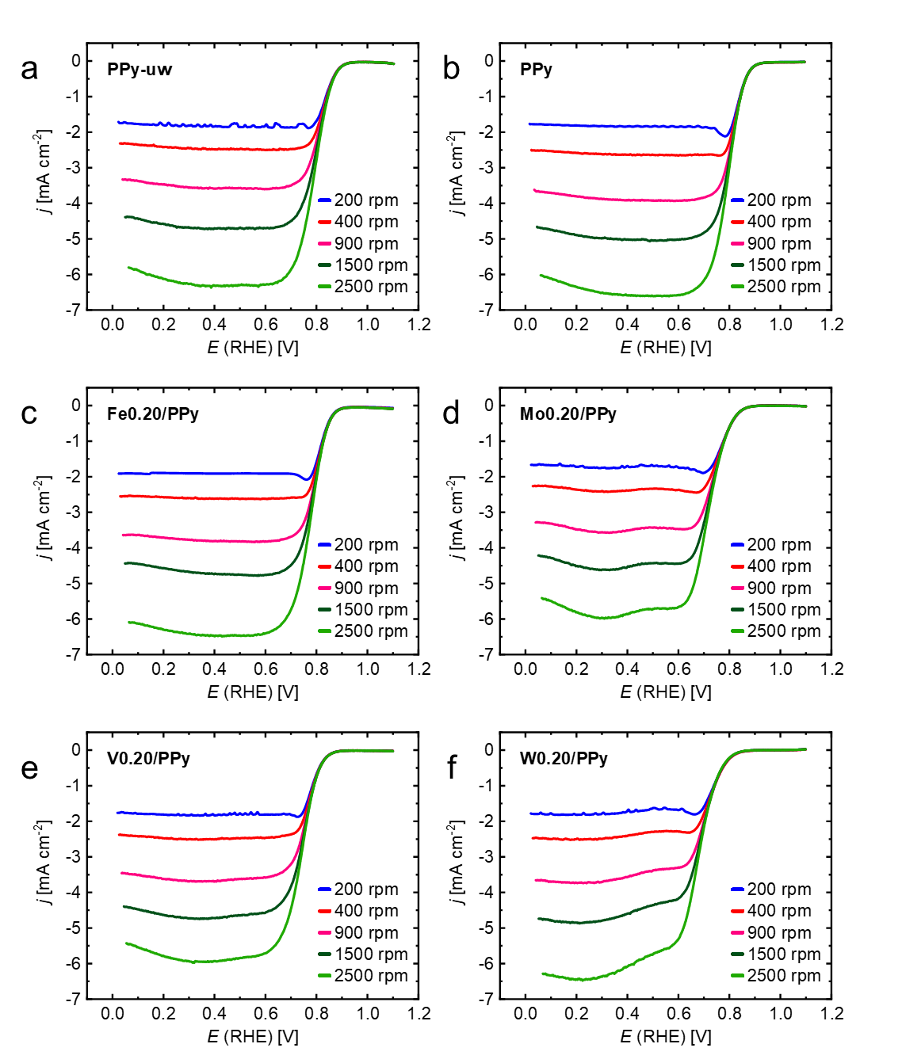
Figure S3: ORR curves recorded at 200, 400, 900, 1500 and 2500 rpm for (a) PPy-uw, (b) PPy, (c) Fe0.20/PPy, (d) Mo0.20/PPy, (e) V0.20/PPy, (f) W0.20/PPy.
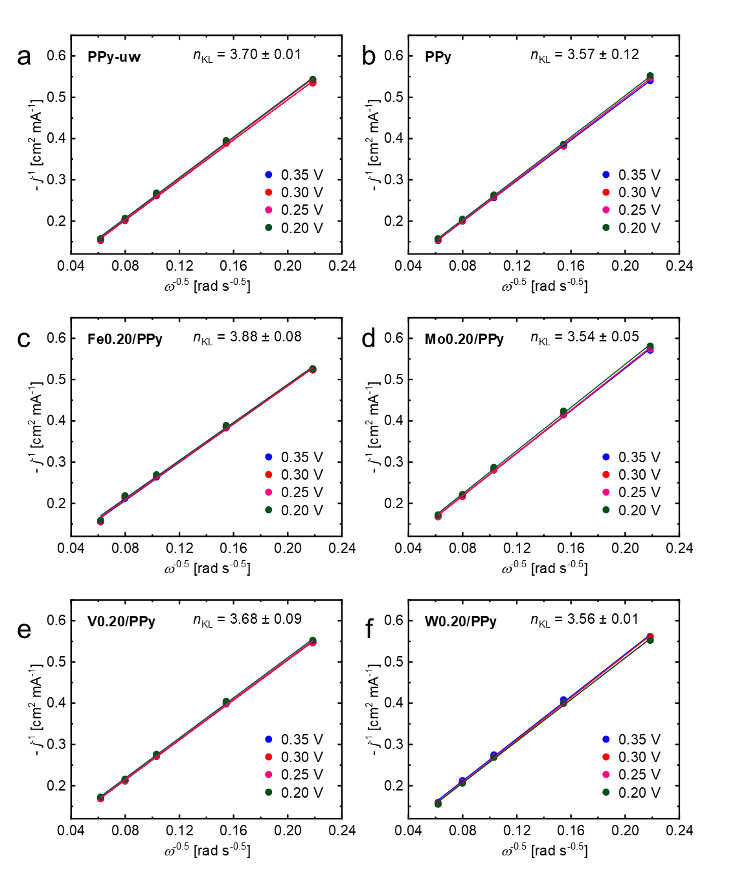
Figure S4: Koutecký-Levich plots of (a) PPy-uw, (b) PPy, (c) Fe0.20/PPy, (d) Mo0.20/PPy, (e) V0.20/PPy, (f) W0.20/PPy.
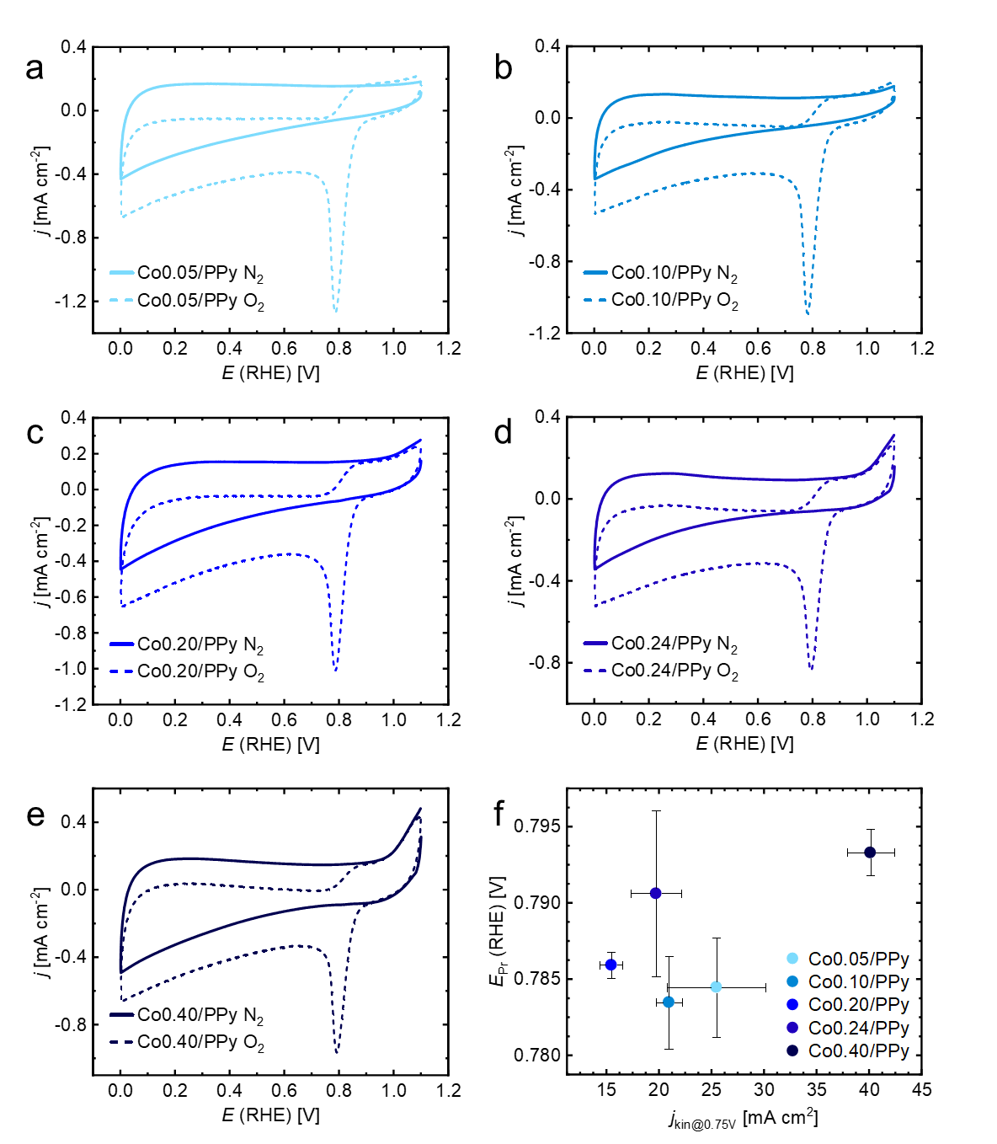
Figure S5: Cyclic voltammograms in N₂- and O₂-saturated electrolyte, recorded at scan rates of 10 mV s^{–1}: (a) Co0.05/PPy, (b) Co0.10/PPy, (c) Co0.20/PPy, (d) Co0.24/PPy, (e) Co0.40/PPy, (f) peak reduction potentials E_{Pr} plotted against kinetic current densities at 0.75 V.

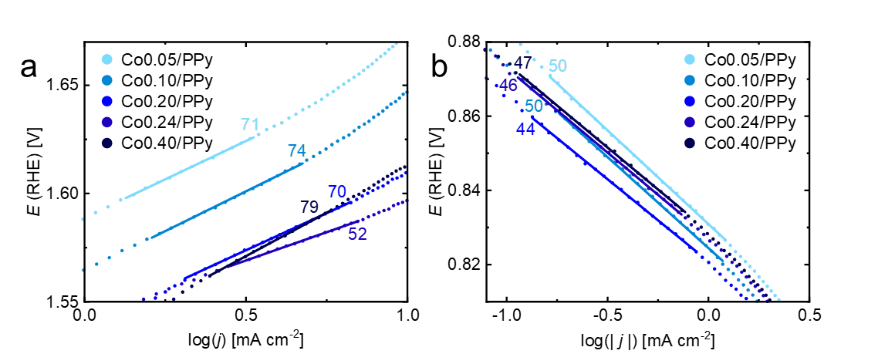
Figure S6: Cobalt loading variation series: (a) OER Tafel plots, (b) ORR Tafel plots, with Tafel slopes in mV dec^{–1}.

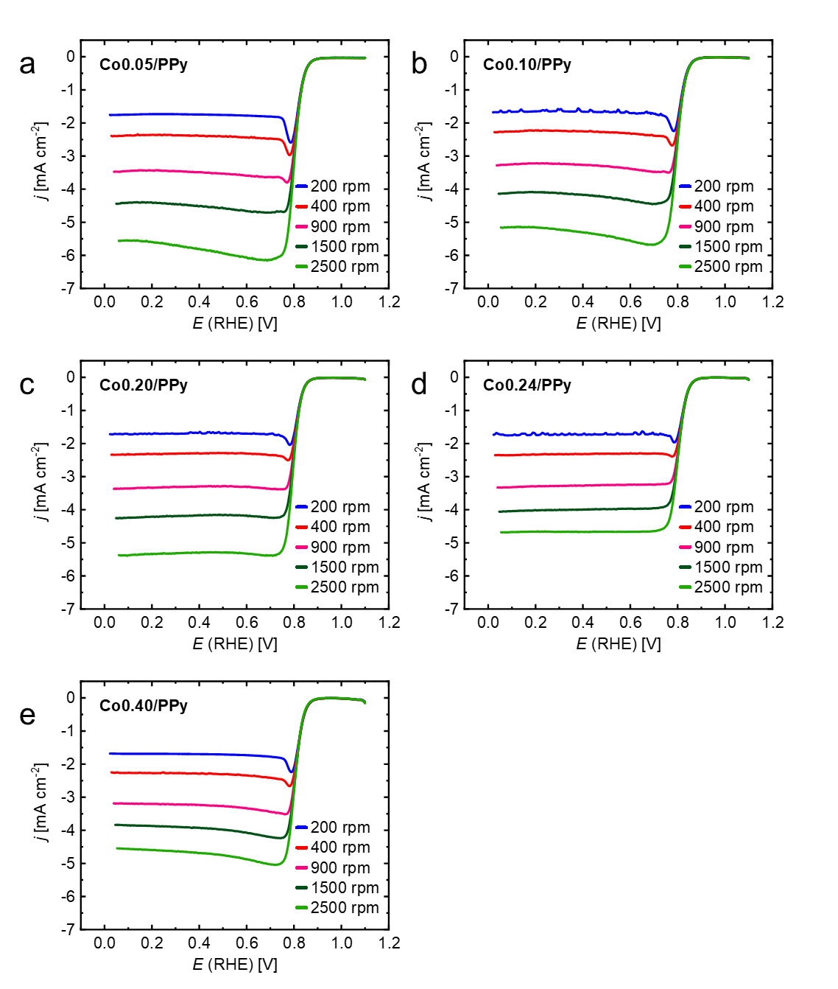
Figure S7: ORR curves recorded at 200, 400, 900, 1500 and 2500 rpm for (a) Co0.05/PPy, (b) Co0.10/PPy, (c) Co0.20/PPy, (d) Co0.24/PPy y, (e) Co0.40/PPy.

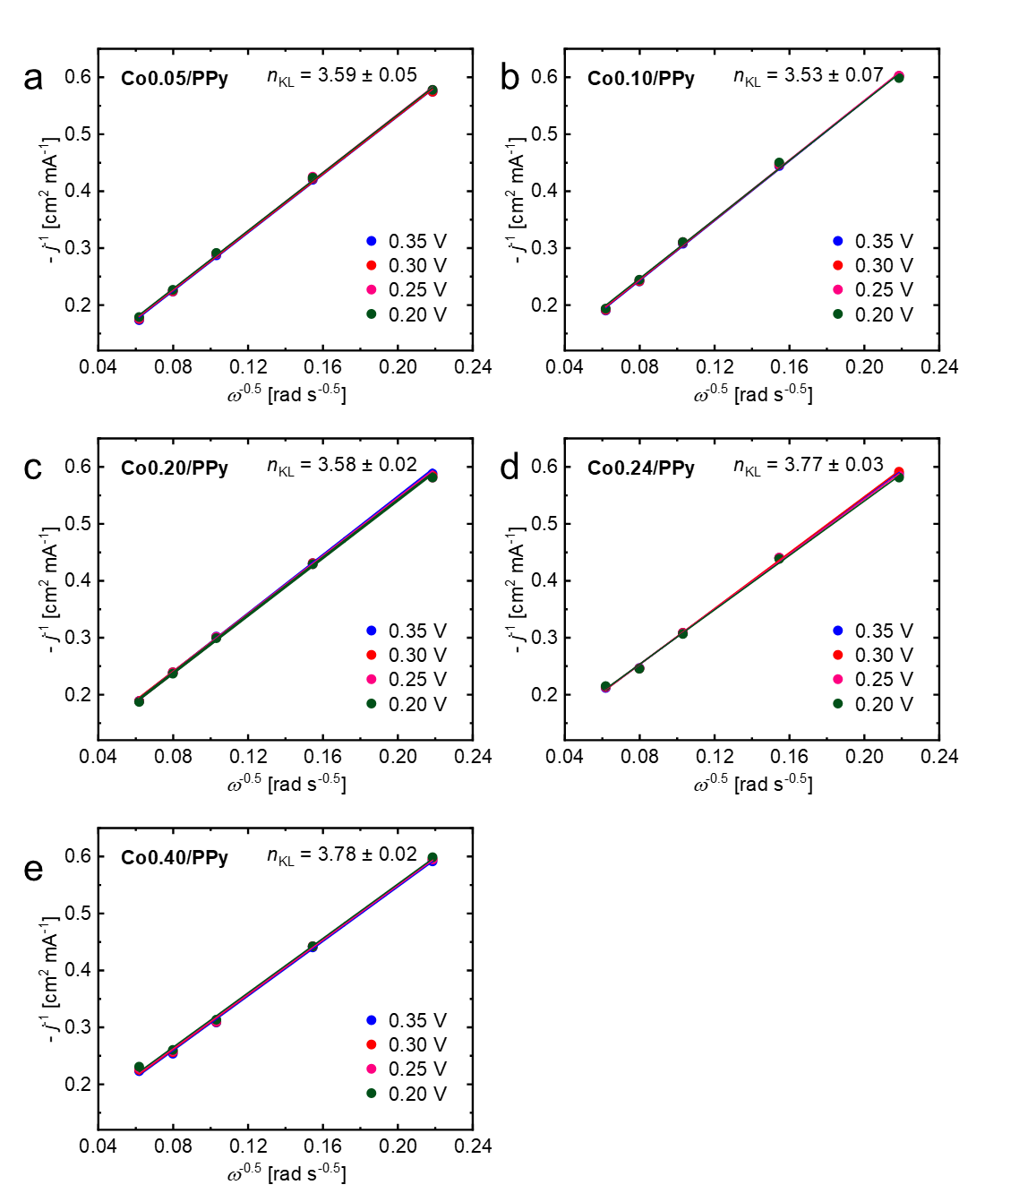
Figure S8: Koutecký-Levich plots for (a) Co0.05/PPy, (b) Co0.10/PPy, (c) Co0.20/PPy, (d) Co0.24/PPy y, (e) Co0.40/PPy.

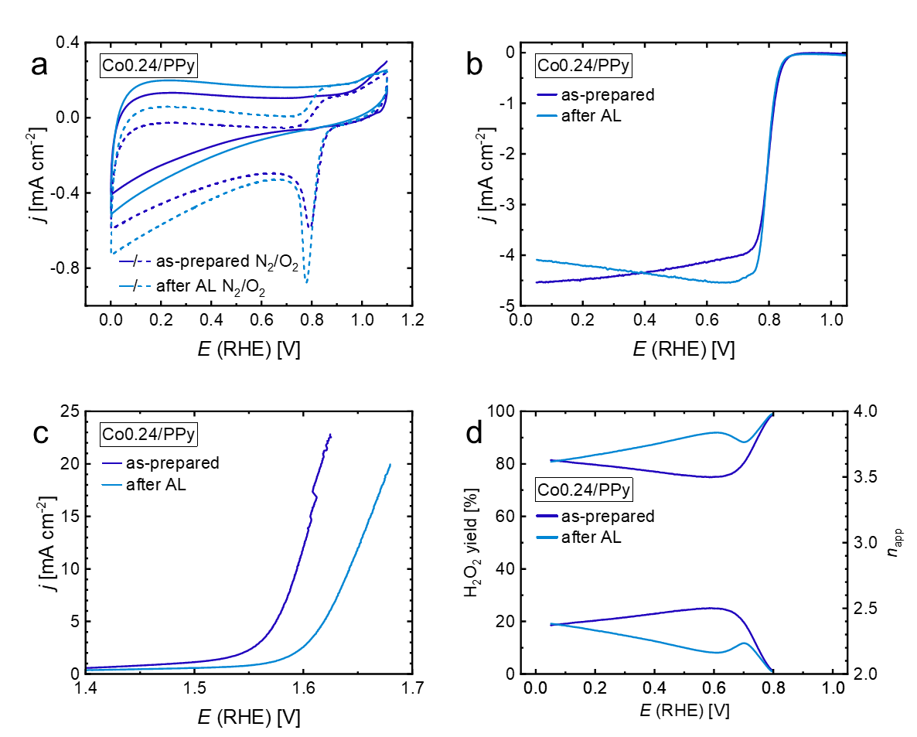
Figure S9: Acid-leaching (AL) of Co0.24/PPy: (a) CVs recorded in N₂- and O₂-saturated electrolyte (0 rpm, 10 mV s⁻¹), (b) ORR curves recorded in O₂-saturated electrolyte (1500 rpm, 10 mV s⁻¹), (c) OER curves recorded in N₂-saturated electrolyte (1500 rpm, 5 mV s⁻¹), (d) peroxide yield and apparent electron transfer number. Please note that the catalyst displayed here was prepared from a different polypyrrole batch as well as a larger microwave pyrolysis batch.

[1] Z. Jia, G. Yin, J. Zhang, Rotating Ring-Disc Electrode Method, in: Rotating electrode methods and oxygen reduction electrocatalysts (Eds: W. Xing, G. Yin, J. Zhang), Elsevier 2014, 199 – 229.
[2] C. Dua, Q. Tana, Yina. G, J. Jiujun Zhangb, Rotating Disk Electrode Method, in: Rotating electrode methods and oxygen reduction electrocatalysts (Eds: W. Xing, G. Yin, J. Zhang), Elsevier 2014, 171 – 198.

