Water Resources Research
Supporting Information for
Stable isotope composition of Cyclone Mekunu rainfall, Southern Oman
Thomas Müller¹*, Jan Friesen², Stephan M. Weise², Omar Al Abri³, Ali Bakhit Ali Bait Said⁴, Nils Michelsen⁵
¹ Department of Hydrogeology, UFZ - Helmholtz Centre for Environmental Research, Leipzig, Germany
² Department of Catchment Hydrology, UFZ - Helmholtz Centre for Environmental Research, Halle, Germany
³ The Research Council, Sultanate of Oman
⁴ Ministry of Regional Municipalities and Water Resources, Salalah, Sultanate of Oman
⁵ Institute of Applied Geosciences, Technische Universität Darmstadt, Darmstadt, Germany

Contents of this file

Figure S1 - Meteosat-8 imagery (visible 0.6 µm) from 02:45 pm (local time) on 25 May 2018 (CIMSS, 2018, modified).
Figure S1 - Results of air mass back-trajectory modeling for 48 h (HYSPLIT; Stein et al., 2015; Rolph et al., 2017).
Figure S3 - a) δ¹⁸O vs rainfall amount for station M2 and b) δ¹⁸O vs distance between storm eye and station M2.
Figure S4 - δ²H-δ¹⁸O relation of Cyclone Mekunu rainfall at station M1.
Figure S5 - δ²H-δ¹⁸O relation of Cyclone Mekunu rainfall at station M2.
Figure S6 - δ²H-δ¹⁸O relation of Cyclone Mekunu rainfall at station M3.
Figure S7 - Temporal development of rainfall amounts and Electrical Conductivities.
Figure S8 - Temporal development of selected major ions for all stations.
Figure S9 - Relation between a) the ion ratio Ca²⁺/Na⁺ and the Na⁺ concentration and b) between the ion ratio SO₄²⁻/Cl⁻ and the Cl⁻ concentration.

Table S1 - Coordinates of the rainfall stations.
Table S2 - Results of the hydrochemical analyses for station M1
Table S3 - Results of the hydrochemical analyses for station M2.
Table S4 - Results of the hydrochemical analyses for station M3.

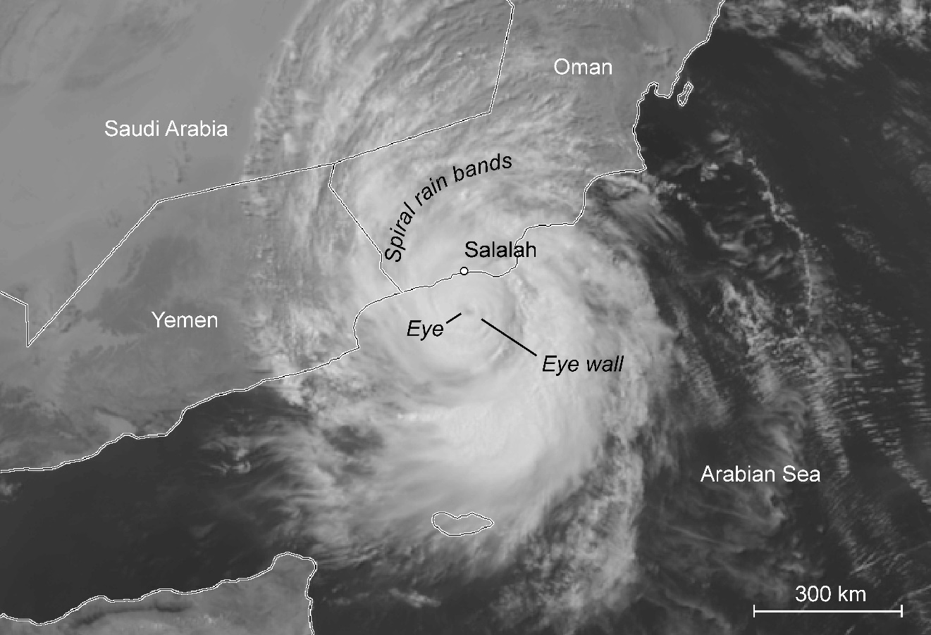
Figure S1. Meteosat-8 imagery (visible 0.6 µm) from 02:45 pm (local time) on 25 May 2018 (CIMSS, 2018, modified). Note the eye, eye wall, and spiral rain bands, as well as the large diameter of the system.

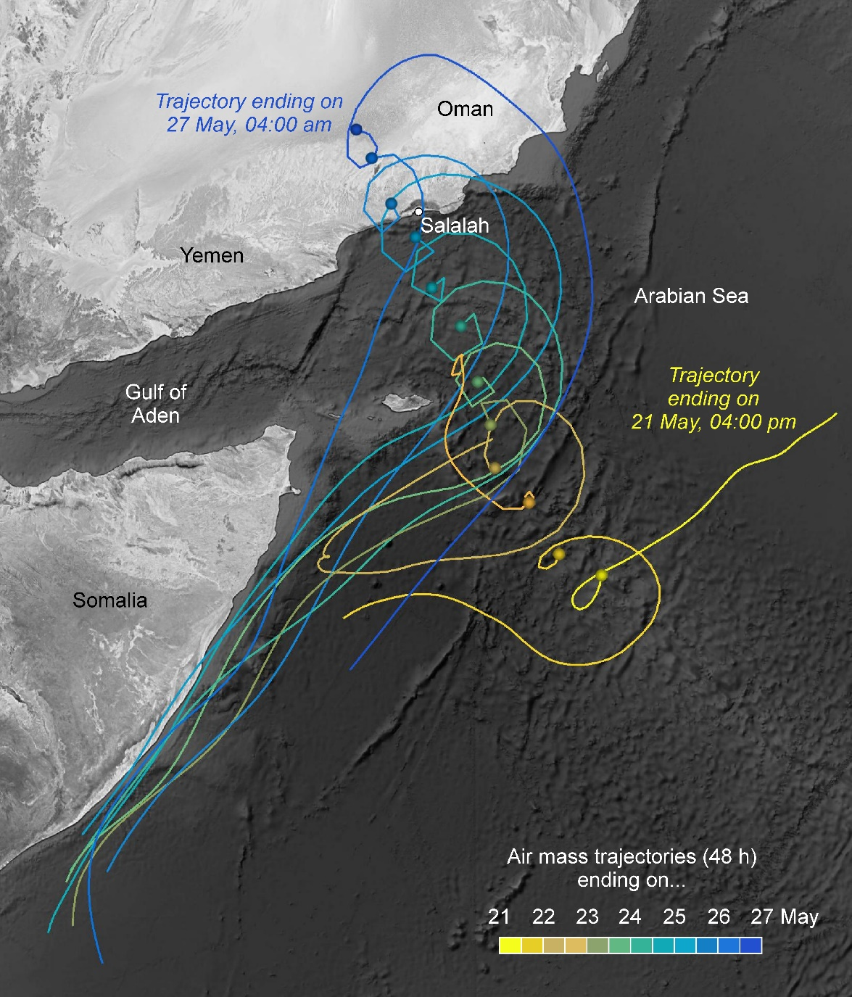
Figure S2. Results of air mass back-trajectory modeling for 48 h (HYSPLIT with GDAS 0.5° meteorology data set; Stein et al., 2015; Rolph et al., 2017). Trajectories were calculated every 12 h (04:00 am and 04:00 pm local time) for air masses reaching the moving storm (about 1,400 km track length) at an altitude of 500 m amsl. Note that contributing air masses mostly originate from the Western Arabian Sea.

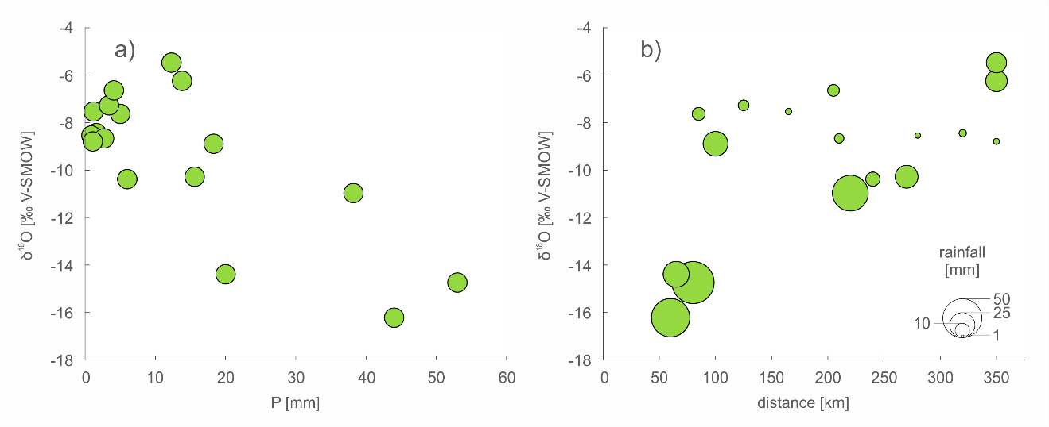
Figure S3. a) δ¹⁸O vs rainfall amount for station M2 and b) δ¹⁸O vs distance between storm eye and station M2. While the R² values for linear regressions are relatively low (not shown), the lightest isotopic signatures are clearly associated with higher rainfall amounts and smaller distances to the cyclone eye.

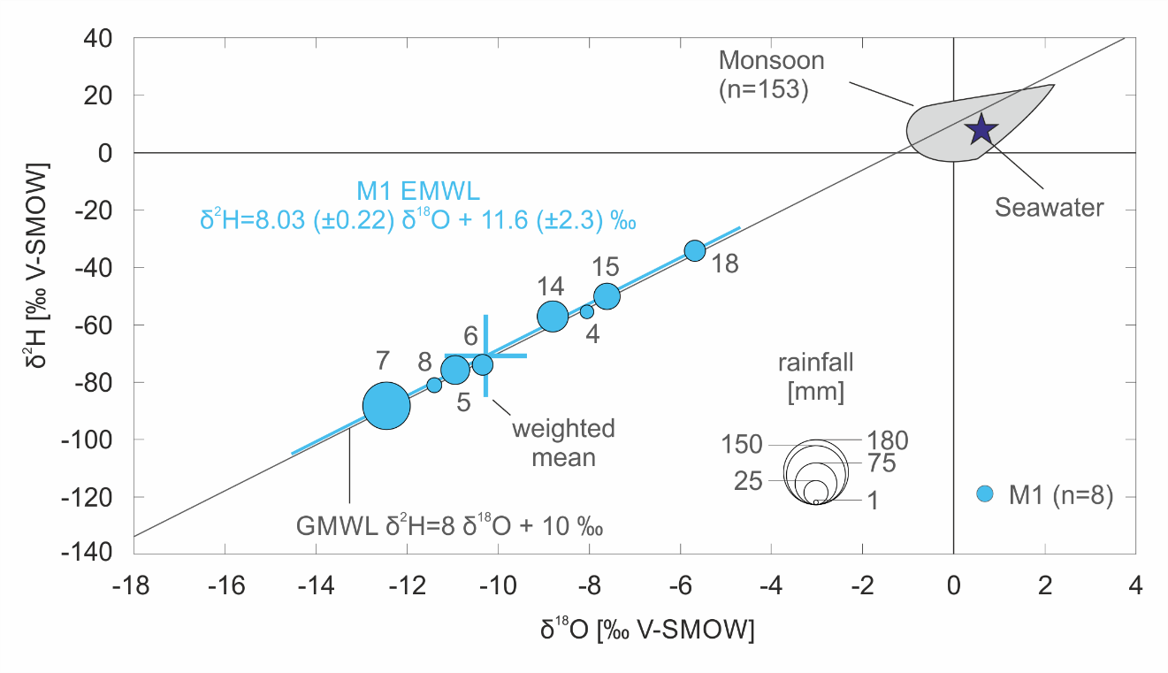Figure S4. δ²H-δ¹⁸O relation of Cyclone Mekunu rainfall at station M1. The sampling intervals (IDs next to the data points) cover 4 h, except for interval 18 (28 h). The Event Meteoric Water Line (EMWL; calculated according to Crawford et al., 2014) closely follows the Global Meteoric Water Line (GMWL; Craig, 1961).

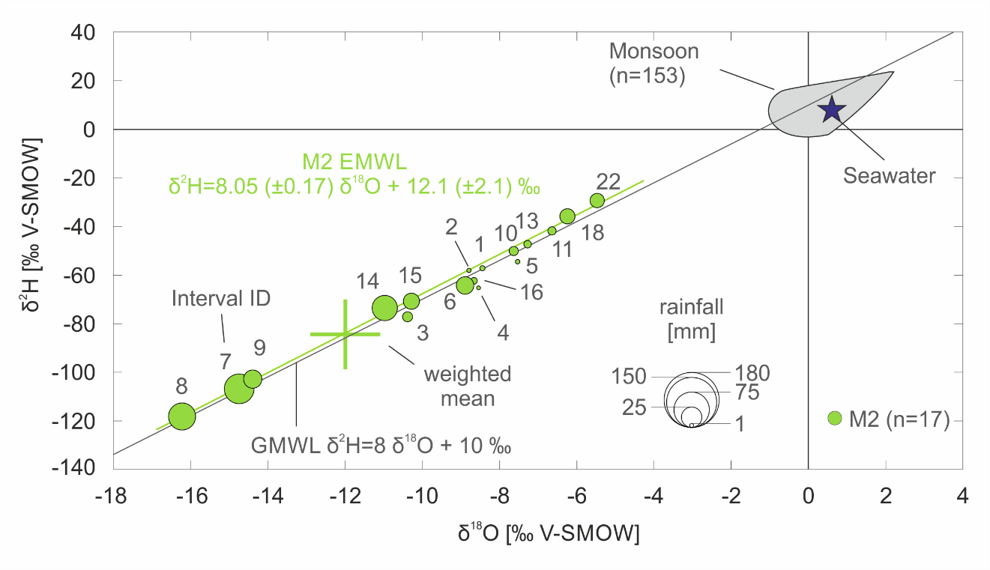
Figure S5. δ²H-δ¹⁸O relation of Cyclone Mekunu rainfall at station M2. The sampling intervals (IDs next to the data points) cover 4 h, except for interval 18 (28 h). The Event Meteoric Water Line (EMWL; calculated according to Crawford et al., 2014) closely follows the Global Meteoric Water Line (GMWL; Craig, 1961).

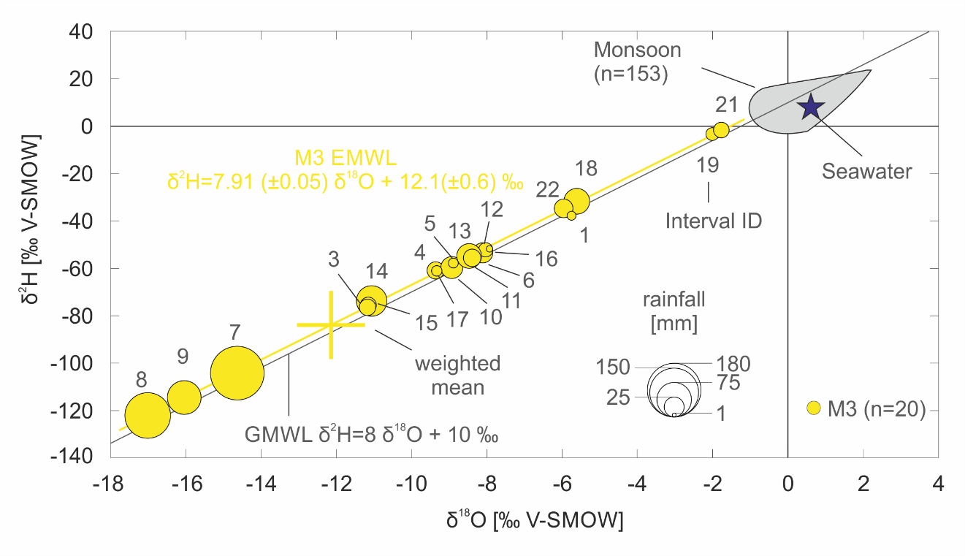
Figure S6. δ²H-δ¹⁸O relation of Cyclone Mekunu rainfall at station M3. The sampling intervals (IDs next to the data points) cover 4 h, except for interval 18 (28 h). The Event Meteoric Water Line (EMWL; calculated according to Crawford et al., 2014) closely follows the Global Meteoric Water Line (GMWL; Craig, 1961).

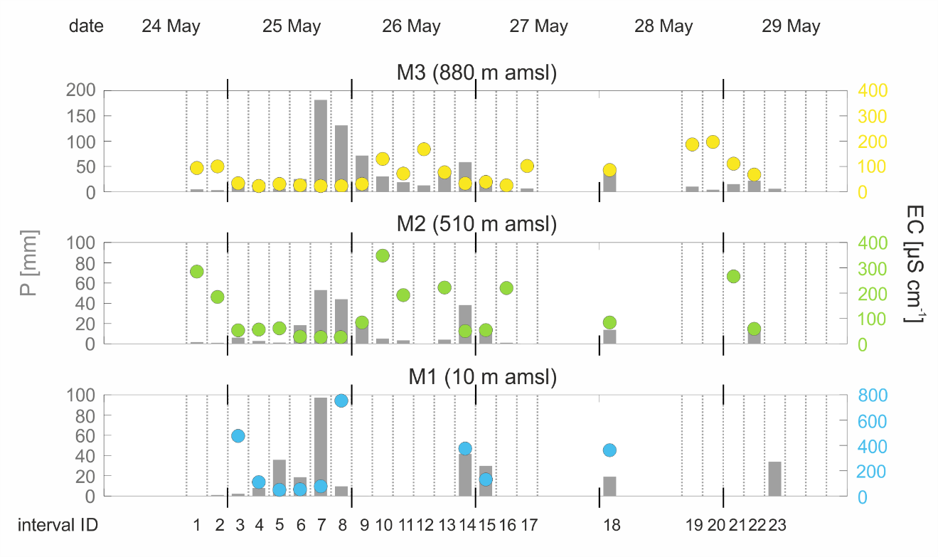
Figure S7. Temporal development of rainfall amounts and electrical conductivities. Decreasing EC values can be observed at the rainfall peak.

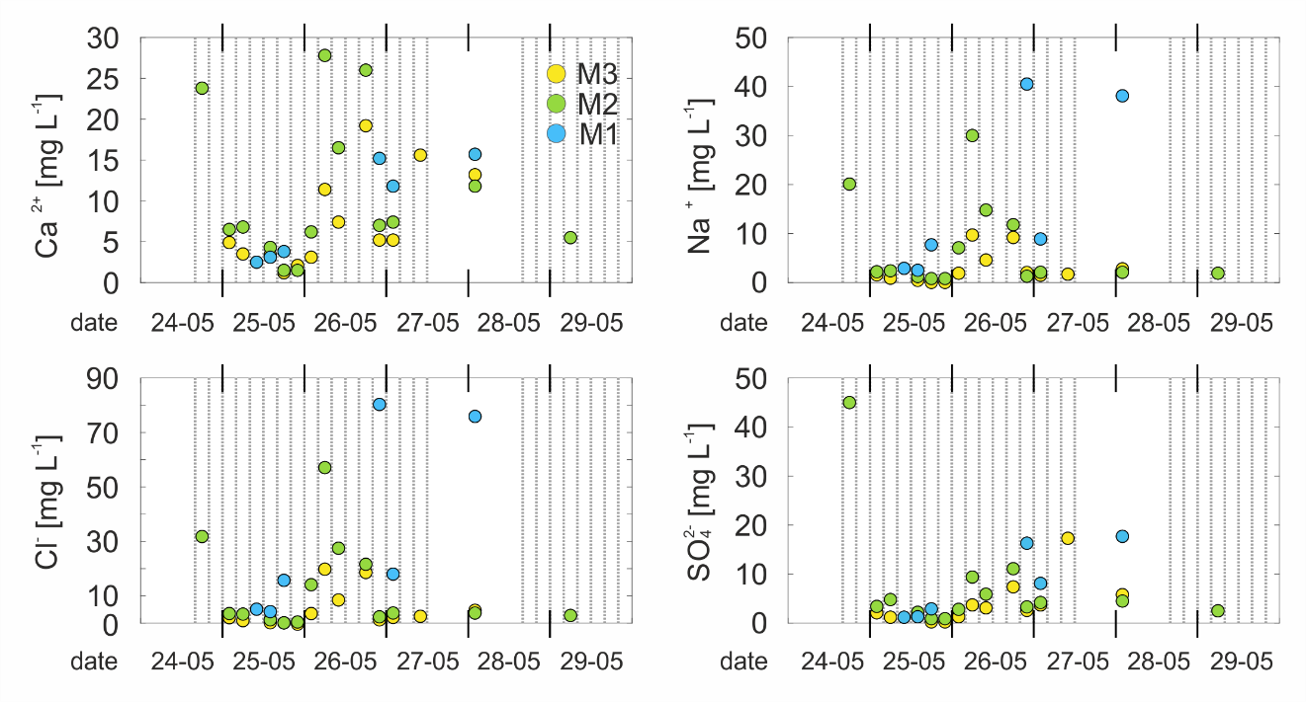
Figure S8. Temporal development of selected major ion concentrations for all stations. Lower concentrations are observed during the rainfall peak, higher concentrations in the following dry intervals.

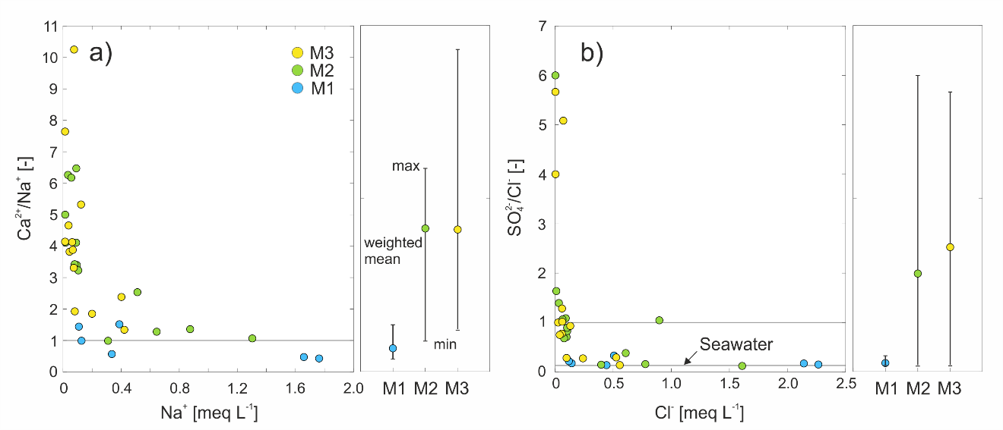
Figure S9. Relation between a) the ion ratio Ca²⁺/Na⁺ and the Na⁺ concentration and b) between the ion ratio SO₄²⁻/Cl⁻ and the Cl⁻ concentration (ion ratios calculated on a meq-basis). The station at the sea (M1) shows a substantial Na⁺ contribution (sea spray proxy), compared to Ca²⁺ (lithogenic proxy), resulting in relatively low Ca²⁺/Na⁺ values (weighted mean < 1). The stations in the mountains (M2 and M3) exhibit higher ratios, indicating a stronger lithogenic component. Accordingly, the ions Cl⁻ (sea spray proxy) and SO₄²⁻ (lithogenic proxy) show the same effect, i.e., SO₄²⁻/Cl⁻ values are much lower for M1 (weighted mean < 1) than for M2 and M3.

Station | Easting | Northing
M1 | 198873 | 1883001
M2 | 193400 | 1902200
M3 | 190000 | 1909800

Table S1. Coordinates of the rainfall stations.

ID | date | EC  [µS cm⁻¹] | Ca²⁺  [mg L⁻¹] | Mg²⁺  [mg L⁻¹] | Na⁺  [mg L⁻¹] | K⁺  [mg L⁻¹] | Cl⁻  [mg L⁻¹] | SO₄²⁻  [mg L⁻¹] | Ca²⁺/ Na⁺ | SO₄²⁻/ Cl⁻
 |  |  |  |  |  |  |  |  | [-] | [-]
1 | 24 May
2 | 24 May
3 | 24 May
4 | 25 May
5 | 25 May | 33 | 2.5 | 0.4 | 2.9 | 0.1 | 5.1 | 1.2 | 0.99 | 0.18
6 | 25 May | 33 | 3.1 | 0.3 | 2.5 | 0.2 | 4.2 | 1.3 | 1.44 | 0.22
7 | 25 May | 77 | 3.8 | 1.1 | 7.7 | 0.6 | 15.7 | 2.9 | 0.57 | 0.14
8 | 25 May
9 | 25 May
10 | 26 May
11 | 26 May
12 | 26 May
13 | 26 May
14 | 26 May | 375 | 15.2 | 6.3 | 40.5 | 1.7 | 80.3 | 16.3 | 0.43 | 0.15
15 | 26 May | 131 | 11.8 | 1.5 | 8.9 | 0.4 | 18.0 | 8.1 | 1.51 | 0.33
16 | 27 May
17 | 27 May
18 | 27 May | 362 | 15.7 | 5.8 | 38.1 | 1.8 | 75.9 | 17.7 | 0.47 | 0.17
19 | 28 May
20 | 28 May
21 | 28 May
22 | 29 May
23 | 29 May
 | Min |  | 2.5 | 0.3 | 2.5 | 0.1 | 4.2 | 1.2 | 0.43 | 0.14
 | Max |  | 15.7 | 6.3 | 40.5 | 1.8 | 80.3 | 17.7 | 1.51 | 0.33
 | Weighted mean |  | 7.5 | 2.3 | 14.8 | 0.8 | 29.4 | 6.6 | 0.78 | 0.18
Table S2. Results of the hydrochemical analyses for station M1. Ion ratios are calculated on a meq-basis.
ID | date | EC  [µS cm⁻¹] | Ca²⁺  [mg L⁻¹] | Mg²⁺  [mg L⁻¹] | Na⁺  [mg L⁻¹] | K⁺  [mg L⁻¹] | Cl⁻  [mg L⁻¹] | SO₄²⁻  [mg L⁻¹] | Ca²⁺/ Na⁺ | SO₄²⁻/ Cl⁻
 |  |  |  |  |  |  |  |  | [-] | [-]
1 | 24 May | 285 | 23.8 | 2.7 | 20.1 | 4.8 | 31.8 | 45.0 | 1.36 | 1.05
2 | 24 May
3 | 24 May | 53 | 6.5 | 0.5 | 2.2 | 0.5 | 3.5 | 3.4 | 3.39 | 0.71
4 | 25 May | 56 | 6.8 | 0.5 | 2.4 | 0.6 | 3.3 | 4.8 | 3.24 | 1.08
5 | 25 May
6 | 25 May | 28 | 4.3 | 0.3 | 0.8 | 0.2 | 1.2 | 2.2 | 6.19 | 1.41
7 | 25 May | 8 | 1.5 | 0.1 | 0.4 | 0.1 | 0.1 | 0.9 | 4.90 | 5.34
8 | 25 May | 8 | 1.5 | 0.1 | 0.4 | 0.1 | 0.4 | 0.9 | 3.98 | 1.62
9 | 25 May | 84 | 6.2 | 1.3 | 7.1 | 0.7 | 14.1 | 2.8 | 0.99 | 0.15
10 | 26 May | 348 | 27.8 | 5.1 | 30.0 | 1.3 | 57.1 | 9.4 | 1.07 | 0.12
11 | 26 May | 192 | 16.5 | 3.3 | 14.8 | 0.7 | 27.5 | 5.9 | 1.28 | 0.16
12 | 26 May
13 | 26 May | 222 | 26.0 | 3.5 | 11.8 | 0.5 | 21.6 | 11.1 | 2.54 | 0.38
14 | 26 May | 50 | 7.0 | 0.8 | 1.3 | 0.1 | 2.3 | 3.3 | 6.16 | 1.07
15 | 26 May | 54 | 7.4 | 0.8 | 2.1 | 0.5 | 3.7 | 4.2 | 4.13 | 0.83
16 | 27 May
17 | 27 May
18 | 27 May | 84 | 11.8 | 1.3 | 2.1 | 0.3 | 3.7 | 4.5 | 6.44 | 0.89
19 | 28 May
20 | 28 May
21 | 28 May
22 | 29 May
23 | 29 May | 59 | 5.5 | 0.9 | 1.9 | 0.2 | 2.8 | 2.5 | 3.41 | 0.67
 | Min |  | 1.5 | 0.1 | 0.4 | 0.1 | 0.1 | 0.9 | 1.0 | 0.1
 | Max |  | 27.8 | 5.1 | 30.0 | 4.8 | 57.1 | 45.0 | 6.4 | 5.3
 | Weighted mean |  | 5.7 | 0.7 | 2.6 | 0.3 | 4.6 | 2.9 | 4.4 | 1.97

Table S3. Results of the hydrochemical analyses for station M2. Ion ratios are calculated on a meq-basis.
ID | date | EC  [µS cm⁻¹] | Ca²⁺  [mg L⁻¹] | Mg²⁺  [mg L⁻¹] | Na⁺  [mg L⁻¹] | K⁺  [mg L⁻¹] | Cl⁻  [mg L⁻¹] | SO₄²⁻  [mg L⁻¹] | Ca²⁺/ Na⁺ | SO₄²⁻/ Cl⁻
 |  |  |  |  |  |  |  |  | [-] | [-]
1 | 24 May
2 | 24 May
3 | 24 May | 34 | 4.9 | 0.3 | 1.7 | 0.6 | 2.0 | 2.1 | 3.31 | 0.77
4 | 25 May | 23 | 3.5 | 0.2 | 0.9 | 0.3 | 0.9 | 1.2 | 4.60 | 0.97
5 | 25 May
6 | 25 May | 26 | 3.4 | 0.2 | 1.0 | 0.4 | 1.4 | 1.4 | 3.84 | 0.75
7 | 25 May | 6 | 1.2 | 0.1 | 0.3 | 0.1 | 0.1 | 0.8 | 4.11 | 4.80
8 | 25 May | 12 | 2.1 | 0.2 | 0.3 | 0.1 | 0.1 | 0.8 | 7.63 | 4.25
9 | 25 May | 31 | 3.1 | 0.4 | 1.9 | 0.3 | 3.5 | 1.3 | 1.92 | 0.28
10 | 26 May | 130 | 11.4 | 1.6 | 9.7 | 0.7 | 19.8 | 3.7 | 1.34 | 0.14
11 | 26 May | 72 | 7.4 | 1.1 | 4.6 | 0.5 | 8.5 | 3.1 | 1.85 | 0.27
12 | 26 May
13 | 26 May | 77 | 19.2 | 1.8 | 9.2 | 1.1 | 18.6 | 7.4 | 2.38 | 0.29
14 | 26 May | 33 | 5.2 | 0.5 | 1.5 | 0.4 | 2.2 | 3.0 | 3.88 | 1.01
15 | 26 May | 39 | 5.2 | 0.5 | 1.5 | 0.3 | 2.1 | 3.7 | 4.11 | 1.27
16 | 27 May
17 | 27 May | 102 | 15.6 | 1.2 | 1.7 | 0.3 | 2.5 | 17.3 | 10.31 | 5.10
18 | 27 May | 86 | 13.2 | 1.5 | 2.8 | 0.7 | 4.7 | 5.8 | 5.33 | 0.92
19 | 28 May
20 | 28 May
21 | 28 May
22 | 29 May
23 | 29 May
 | Min |  | 1.2 | 0.1 | 0.3 | 0.1 | 0.1 | 0.8 | 1.34 | 0.14
 | Max |  | 19.2 | 1.8 | 9.7 | 1.1 | 19.8 | 17.3 | 10.31 | 5.10
 | Weighted mean |  | 4.91 | 0.5 | 2.0 | 0.3 | 3.4 | 2.3 | 4.39 | 2.55

Table S4. Results of the hydrochemical analyses for station M3. Ion ratios are calculated on a meq-basis.

