Supporting Information

Evaluation of Mechanical Properties and Hydrophobicity of Room-Temperature, Moisture-Curable Polysilazane Coatings
Ying Zhan ^{a,} *, Ralf Grottenmüller ^{b}, Wei Li ª, Farhan Javaid ^{a, c}, Ralf Riedel ^{a,} *
^{a.} Institute of Materials and Earth Sciences, Technical University of Darmstadt, D-64287 Darmstadt, Germany
^{b.} Merck KGaA, D-64293 Darmstadt, Germany
^{c.} School of Chemical and Materials Engineering, National University of Sciences & Technology, 44000 Islamabad, Pakistan
*. Corresponding authors: ying.zhan@tu-darmstadt.de (Y. Zhan), ralf.riedel@tu-darmstadt.de (R. Riedel)

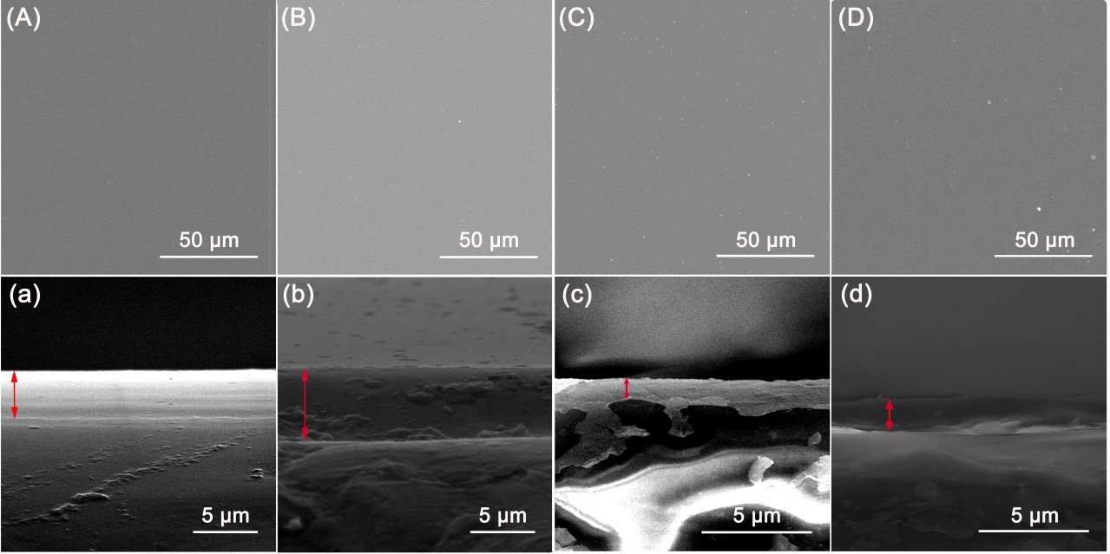
Figure S1. SEM images of the (A-D) surface and (a-d) cross-section of D1500-sc, D1800, D2250, D2850 coatings, respectively, cured in ambient environment and temperature for 30 days.

