Supporting Information
Towards a Greener and Scalable Synthesis of Na₂Ti₆O₁₃ Nanorods and Its Application as Anode in Batteries for Grid-Level Energy Storage
Dario M. De Carolis,*^{[a]} Dragoljub Vrankovic,^{[a,1]}SamiraA. Kiefer,^{[a]} Enrico Bruder,^{[b]}Michael T. Dürrschnabel,^{[c]} Leopoldo Molina-Luna,^{[d]} Magdalena Graczyk-Zajac,^{[a,2]} Ralf Riedel^{[a]}

[a] Dispersive Solids (DF) Division, Materials Science, Technical University of Darmstadt, Otto-Berndt-Straße 3, D-64287, Darmstadt, Germany
[b] Physical Metallurgy Division, Materials Science, Technical University of Darmstadt, Alarich-Weiss-Straße 2, D-64287, Darmstadt, Germany
[c] Institute for Applied Materials – Applied Material Physics (IAM-AWP), Karlsruhe Institute of Technology (KIT), Hermann-von-Helmholtz-Platz 1, 76344 Eggenstein-Leopoldshafen, Germany
[d] Advanced Electron Microscopy (AEM) Division, Materials Science, Technical University of Darmstadt, Alarich-Weiss-Straße 2, 64287 Darmstadt, Germany
[1]Presentaddress: Mercedes-Benz AG, Mercedesstraße 120, 70327 Stuttgart, Germany
[2]Presentaddress: EnBW Energie Baden-Württemberg AG, Durlacher Allee 93, 76131 Karlsruhe, Germany

EBSD
Figure S 1 presents EBSD measurements of samples NTO-900 and NTO-1100. Note that the EBSD on NTO-1100 was performed on a different spot than that shown in Figure 2. As a result, all samples show the same growth direction, i.e. growth along <010>.
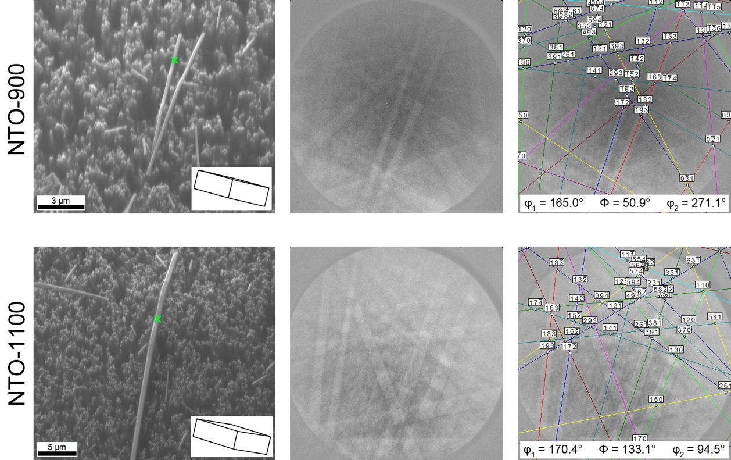
Figure S 1. EBSD data of sample NTO-900 (first line) and NTO-1100 (second line). The representation follows the pattern of the manuscript.

SEM
Figure S 2and Figure S 3present SEM micrographs of NTO-900 and NTO-1100 at lower and at higher magnification. It is clear from the first glance that the nanorods average thicknessin NTO-1100 is about 50% larger than that in NTO-900. Figure S 3 gives a better overview of the samples providing low magnification micrographs.

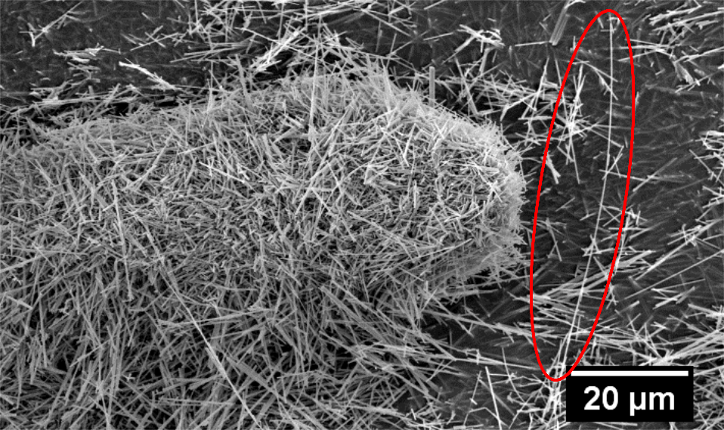
Figure S 2. SEM image reporting nanorods with a length of 40 µm contained in NTO-1100.

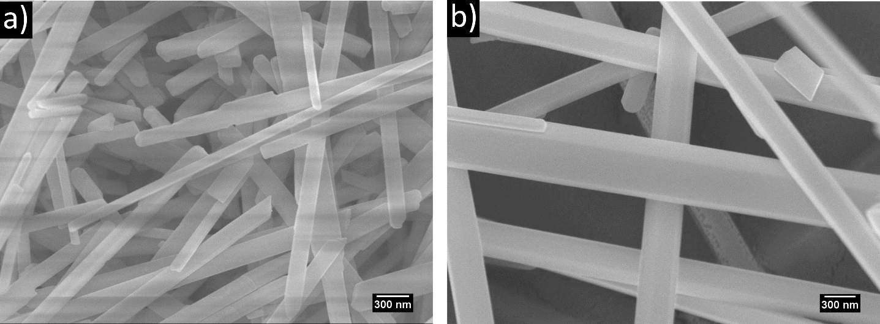
Figure S 3. comparison of the thicknesses of the nanorods synthesized respectively at a) 900 °C (NTO-900) and b) 1100 °C (NTO-900). These two pictures are magnifications of the samples reported in Fig 4a) and 4e).

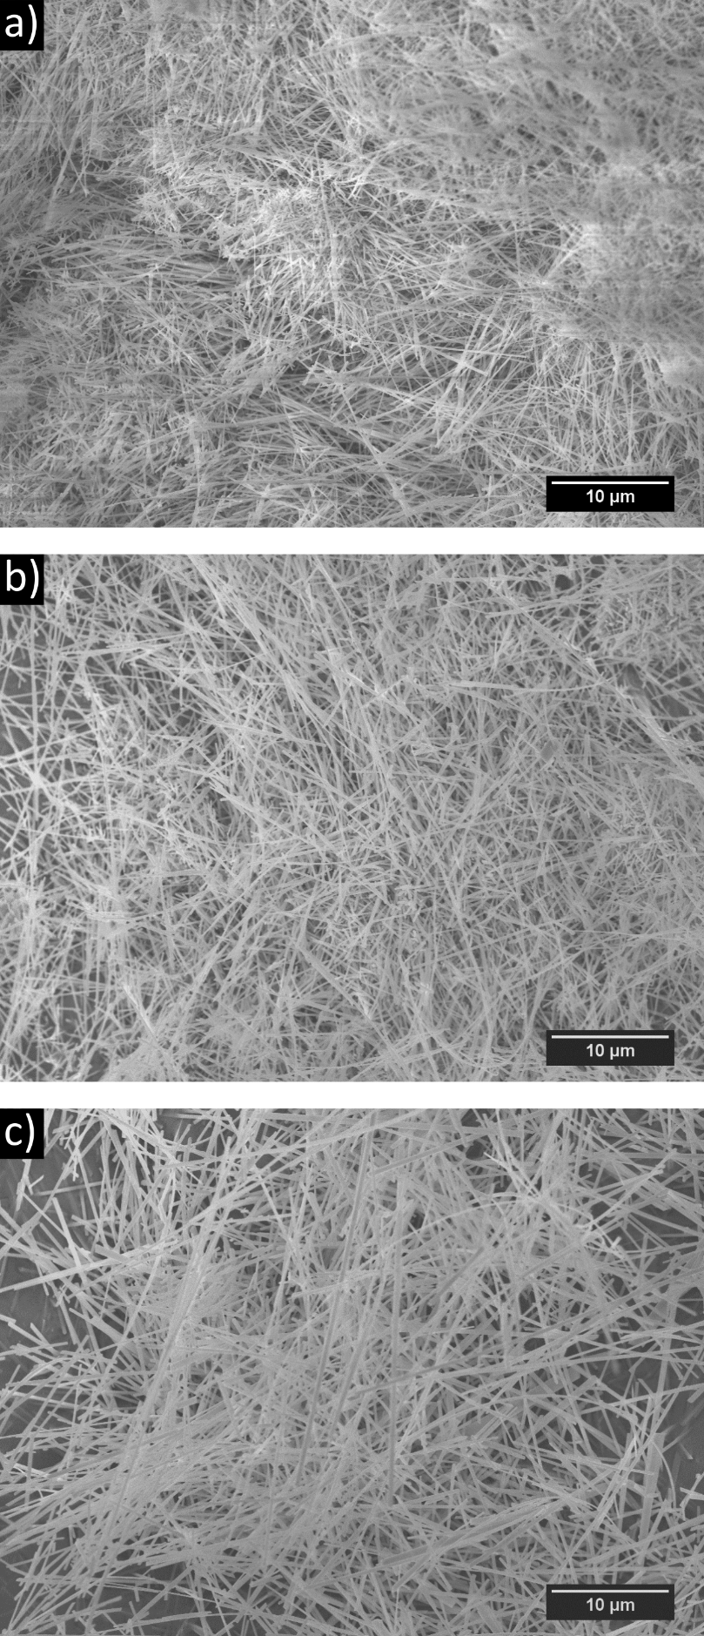
Figure S 4.Low magnification SEM images of a) NTO-900, b) NTO-1000 and c) NTO-1100.
DTA-TGA
Thermogravimetric analysis of the precursor mixture was performed with a STA 429 (TGA/DTA-Sensor), (NetzschGerätebau GmbH, Selb (Bavaria), Germany) in a continuous flow of synthetic air (75 mL/min).
DTA has beenperformed on the dried powder obtained after the first synthesis step. The DTA analysis reveals two strong endothermic peaks at 243.9 °C and 882.1 °C (see Figure S 5). They are attributed to the structural change of Na₂SO₄^{[1]}(phase transition V-I) and to the melting of the salt matrix. These findings are confirmed by the measurement performed on pure Na₂SO₄ (see red curve in Figure S 5). Other endothermic peaks with lower intensity are recorded at 119.8 °C and 974.8 °C. The first is explained by the evaporation of water as confirmed by the TG measurement (mass loss of about 1.2 % of total 1.86wt%). The second peak at 974.8 °C is ascribed to the evaporation of gaseous species like SO_{x}. According to Sauvet et al.^{[2]} Na₂Ti₆O₁₃ crystallization process is exothermic, taking place at a lower temperature (463.7 °C). However this feature could also be attributed to the crystallization of amorphous anatase.^{[3]} No crystalline anatase is formed in our MSS. Otherwise the characteristic exothermic peak of the transition anatase into rutile would be visible in the temperature range from 700-1100 °C. Therefore, theexothermic peak at 463.7 °C (see inset in Figure S 5) can be addressed to thecrystallization of Na₂Ti₆O₁₃.The rather low intensity might be ascribed to the composition of the measured powder, consisting of more than 90% of Na₂SO₄.
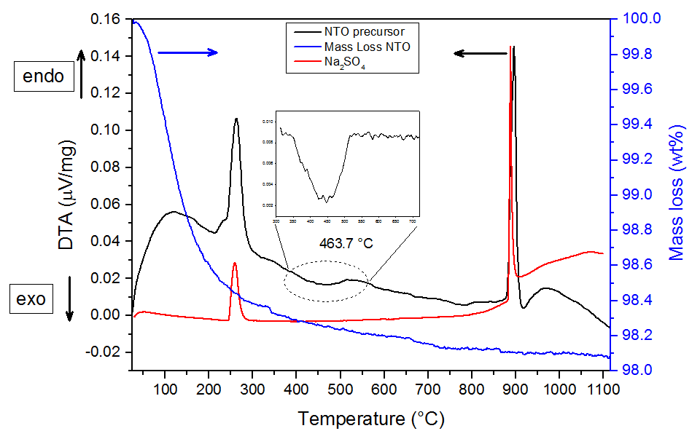
Figure S 5. DTA (black line) and TG (blue line) measurement performed on the NTO precursor. The DTA of Na₂SO₄ is reported for comparison (red line). The inset shows a magnification of the exothermic peak at 463.7 °C with baseline correction.

Raman spectroscopy
Figure S 6 presents an enlarged view of the Raman data shown in Fig. 5 in the manuscript. The Raman lines of NTO-900 and NTO-1100 have been integrated in order to compare the intensity change with synthesis temperature. While the area of all the lines except 226 cm⁻¹ and 876 cm⁻¹ stay almost constant, the 226 cm⁻¹ linedecreases of about 20% whereas the 876 cm⁻¹ line increasesby about 80% (see Table S 1).
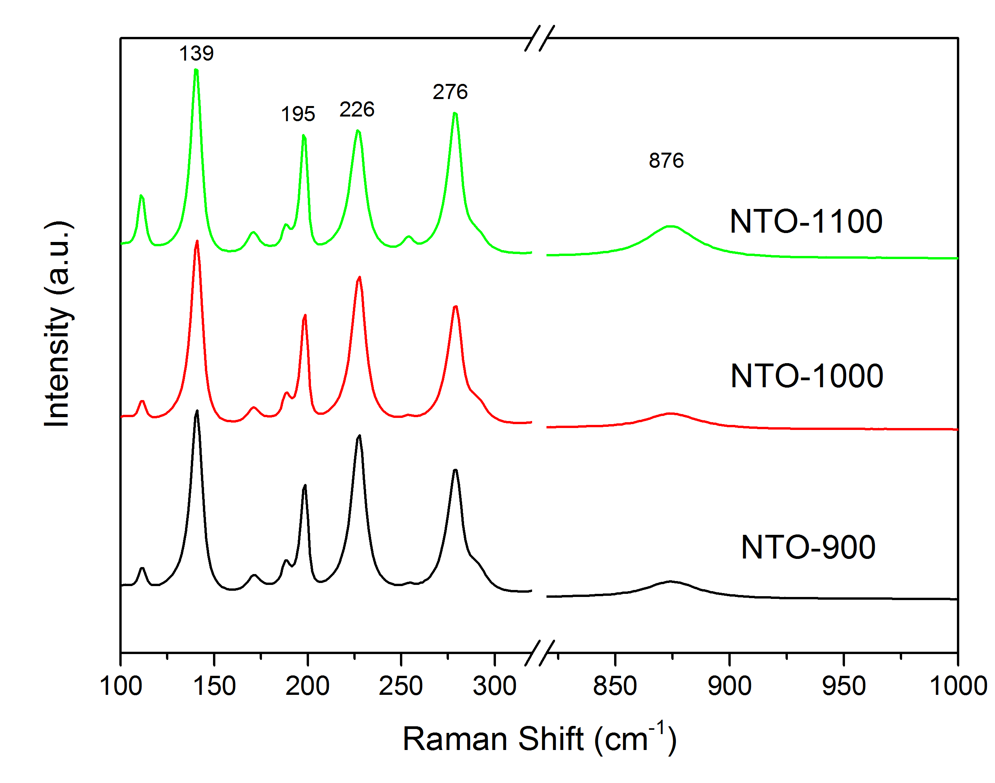
Figure S 6.Enlarged view of Fig. 5, obtained with a brakein the Raman shift. This allows a detailed view on the intensity variations in the Raman measurements depending on the temperature.

Table S 1. integrated peak areas of the Raman lines of sample NTO-900, NTO-1000 and NTO-1100. The area difference is calculated between NTO-900 and NTO-1100.
Integrated peak area of different Raman lines
Sample | 139 cm⁻¹ | 195 cm⁻¹ | 226 cm⁻¹ | 276 cm⁻¹ | 876 cm⁻¹
NTO-900 | 9.21 | 2.71 | 8.56 | 6.34 | 2.34
NTO-1000 | 9.09 | 2.73 | 8.06 | 6.01 | 2.15
NTO-1100 | 8.70 | 3.01 | 6.84 | 6.77 | 4.20
Area change from 900 °C to 1100 °C | -5.59% | 11.23% | -20.11% | 6.75% | 79.49%

FFT patterns from HRTEM
Figure S 7 shows that the acquired FFT pattern of NTO-900 and NTO-1100 agree well with JEMS^{[4]} calculations with the structural data input taken from Perez-Flores^{[5]}. No large discrepancy between experiment and model is being found.
Figure S 7. Comparison of FFT’s calculated from HRTEM images with calculated NTO spot patterns for samples NTO-900 a) and b) and NTO-1100 c) and d), respectively.

EDX
Figure S 8shows the EDX spectra of NTO-900 and NTO-1100 single nanorods, respectively. The additional C and Si peak are due to the surrounding araldite embedding material. The quantification of both spectra is presented in Table S2 below.
Figure S 8. EDX spectra of sample NTO-900 and NTO-1100, respectively. Si and C originate from surrounding araldite.

Table S2. Relative quantification of EDX spectra acquired from a single Na₂Ti₆O₁₃ nanorod using the Cliff-Lorimer k-factor method for both samples.
Sample | Na [at%] | Ti [at%] | O [at%]
k-factor | 0.9432 | 1.0291 | 1.0000
NTO-900 | 8.46 ± 1.93 | 29.16 ± 5.06 | 62.38 ± 6.98
NTO-1100 | 7.10 ± 1.65 | 33.19 ± 5.95 | 59.70 ± 7.20
Nominal | 9.52 | 28.57 | 61.90

Table S2 shows the results of a quantitative EDX analysis via Cliff-Lorimer method. The results agree within experimental error with the nominal composition presented in the last row ofTable S2.

References E.S.I.

[1] S. E. Rasmussen, J. E. Jørgensen, B. Lundtoft, J. Appl. Crystallogr.1996, 29, 42–47.
[2] A.-L. Sauvet, S. Baliteau, C. Lopez, P. Fabry, J. Solid State Chem.2004, 177, 4508–4515.
[3] A. Baszczuk, M. Jasiorski, M. Winnicki, J. Therm. Spray Technol.2018, 27, 1551–1562.
[4] “https://www.jems-swiss.ch/,” n.d.
[5] J. C. Pérez-Flores, F. García-Alvarado, M. Hoelzel, I. Sobrados, J. Sanz, A. Kuhn, Dalt. Trans.2012, 41, 14633–42.

