Supplementary information
XPS measurements of all potential elements on the substrates C, N, O, Pb, I, Ti were conducted and shown in Suppl. Figure 1. The binding energy peak positions are summarized in Suppl. Table 1. No titanium signal was picked up on the pin-hole free measuring spot, so pin holes down to titanium oxide can be ruled out as a component of the surface composition. Thus, two oxygen species O1s a (529.7 eV) and O1s b (532.3 eV) can be attributed to PbO²⁶ resp. Pb(OH)₂²⁷. The C1s a species (286.7 eV) can be attributed to MAPI²⁸ and the C1s b (285.5 eV) to common surface contamination from ex-situ preparation²⁹. A small side peak is visible in the Pb4f spectrum, the main one Pb4f 7/2 b at 138.8 eV belonging to MAPI³⁰, while Pb4f 7/2 a at 137.1 eV belongs to elemental lead (Pb⁰)³¹. The N1s at 402.7 eV belongs to MAPI³⁰ and the I3d 5/2 at 619.6 eV belongs to MAPI³⁰. No titanium is present on the surface of the sample.
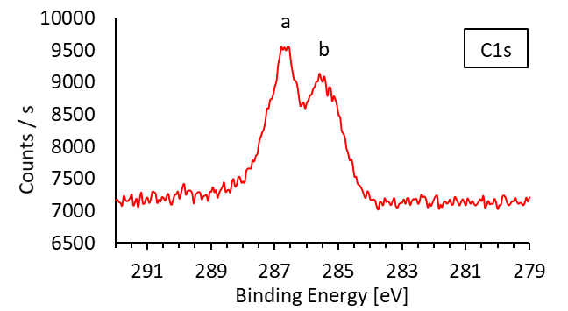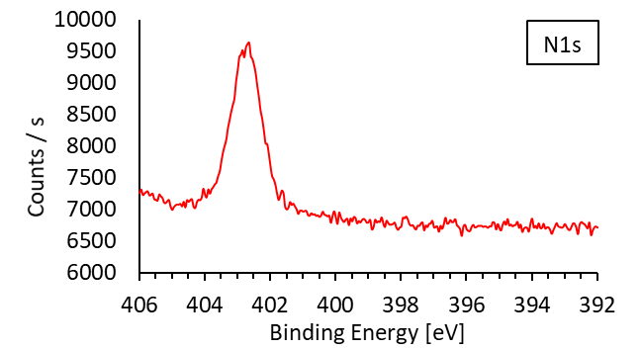
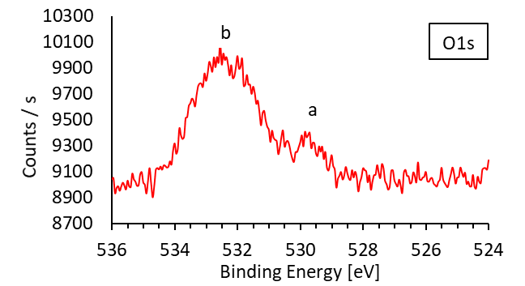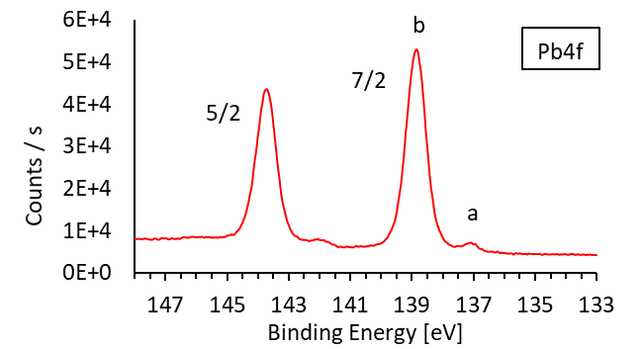
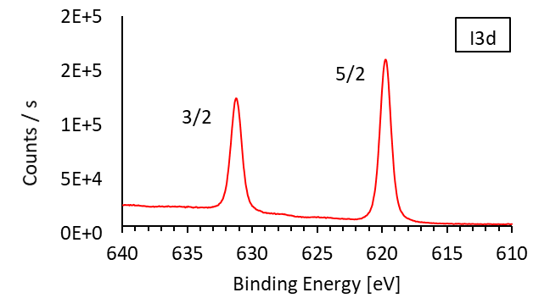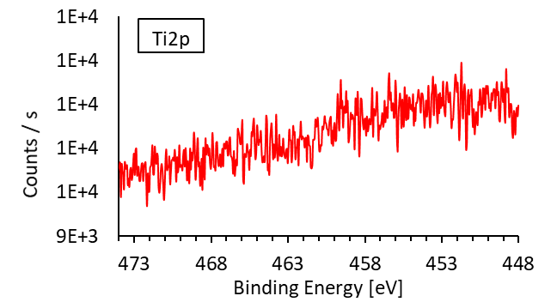
Suppl. Figure 1 Detailed XPS spectra of the elements carbon, nitrogen, oxygen, lead, iodine and titanium, of the 2.5 MA sample, from the last step of the CVD process, produced without the drying agent for the HI step

Suppl. Table 1 XPS core level binding energy positions of the elements found on the 2.5 MA step sample, produced without the drying agent for the HI step (see Suppl. Figure 1)
Species | C1s a | C1s b | N1s | O1s a | O1s b | Pb4f 7/2 a | Pb4f 7/2 b | I3d 5/2
Binding Energy [eV] | 286.7 | 285.4 | 402.7 | 529.7 | 532.3 | 137.1 | 138.8 | 619.7

Suppl. Figure 2 Cross-section SEM images; Left: detail of surface of a spin coated lead iodide layer vs. Right: detail of surface of the MAPI layer after treatment of the lead iodide layer in the CVD process for 0.5 cycles with methylamine. Samples tilted at 70°

The photoluminescence spectrum shown in Suppl. Figure 3 is fitted using a Voigt profile.
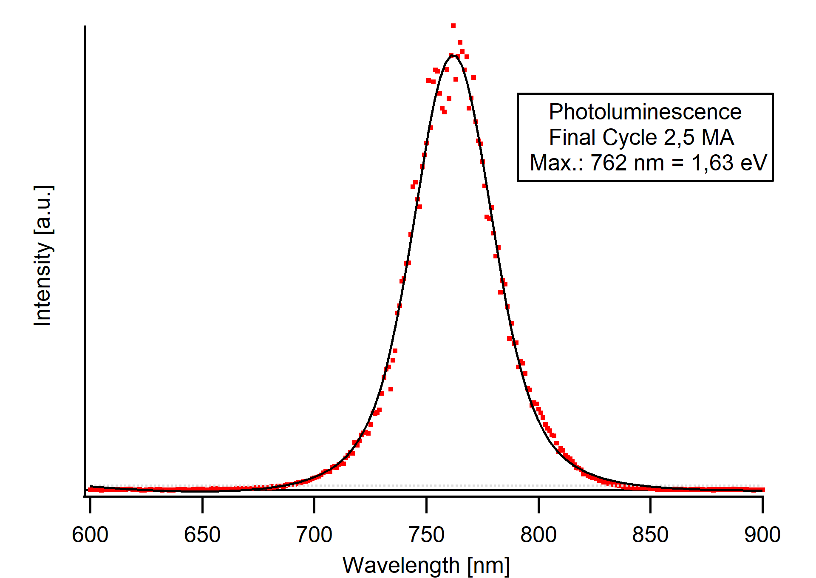
Suppl. Figure 3 Photoluminescence (PL) measurement of the 2.5 MA final cycle of the CVD process, made without the drying agent for the HI step
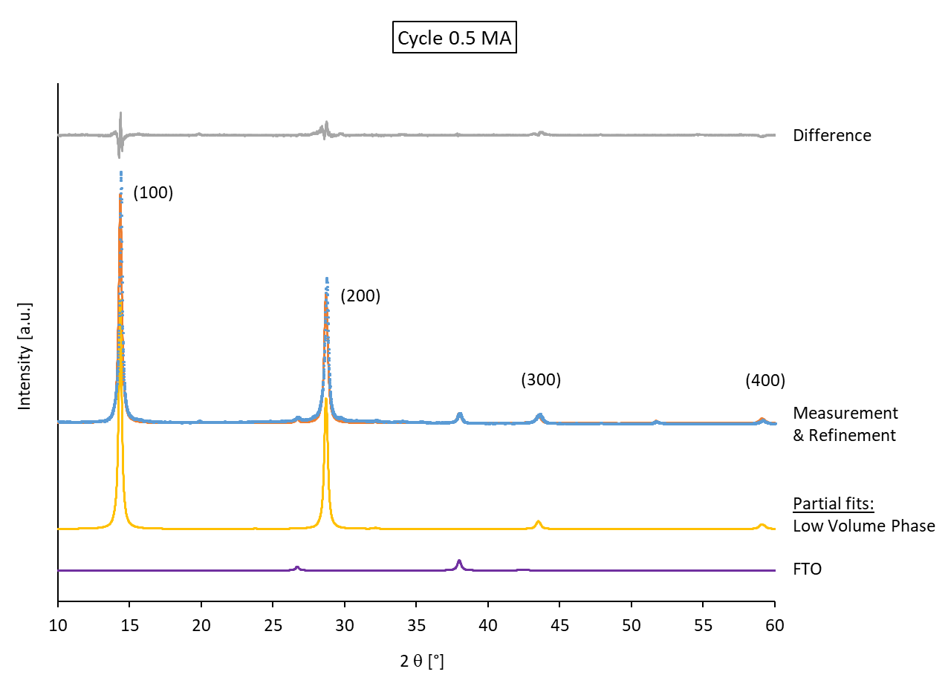
Suppl. Figure 4 XRD pattern and refinements of the 0.5 MA substrate from the CVD process
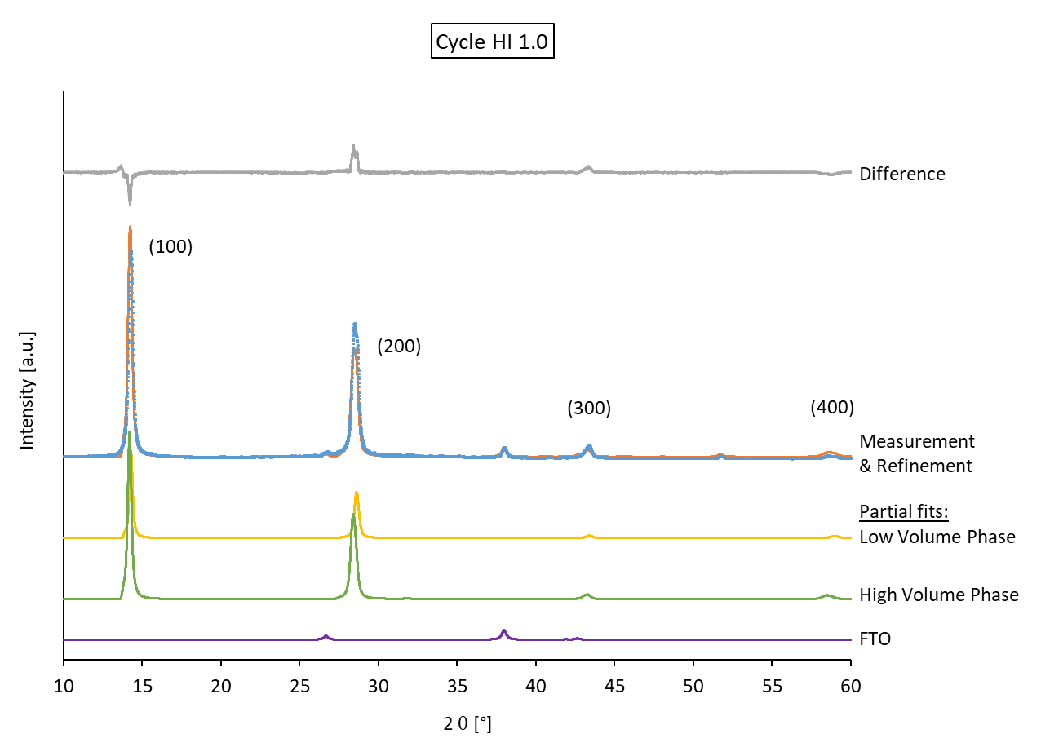
Suppl. Figure 5 XRD pattern and refinements of the 1.0 HI substrate from the CVD process
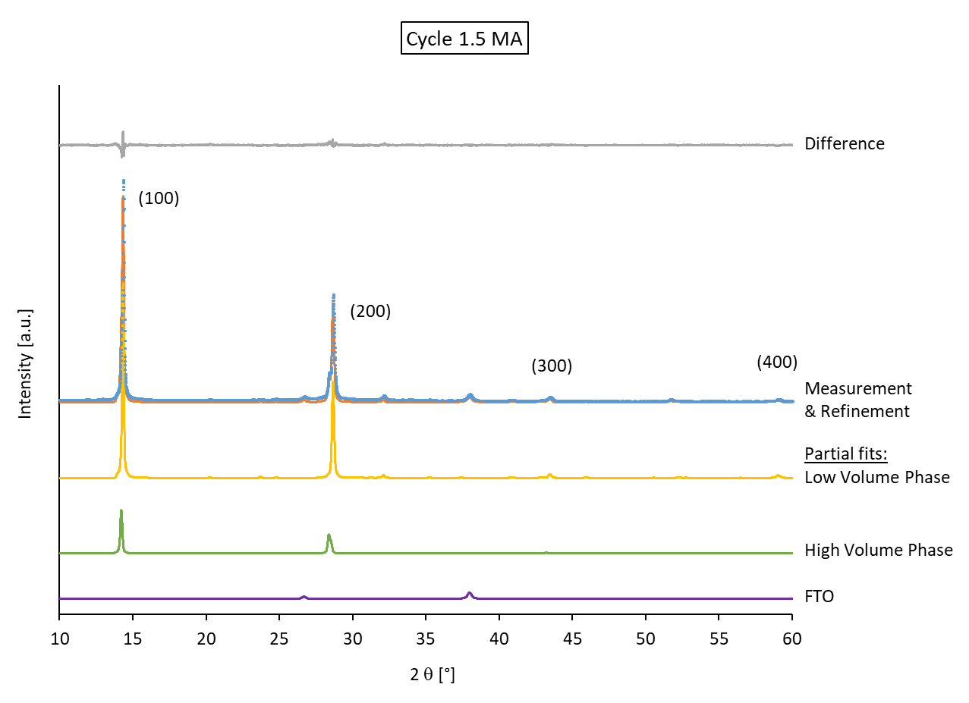
Suppl. Figure 6 XRD pattern and refinements of the 1.5 MA substrate from the CVD process
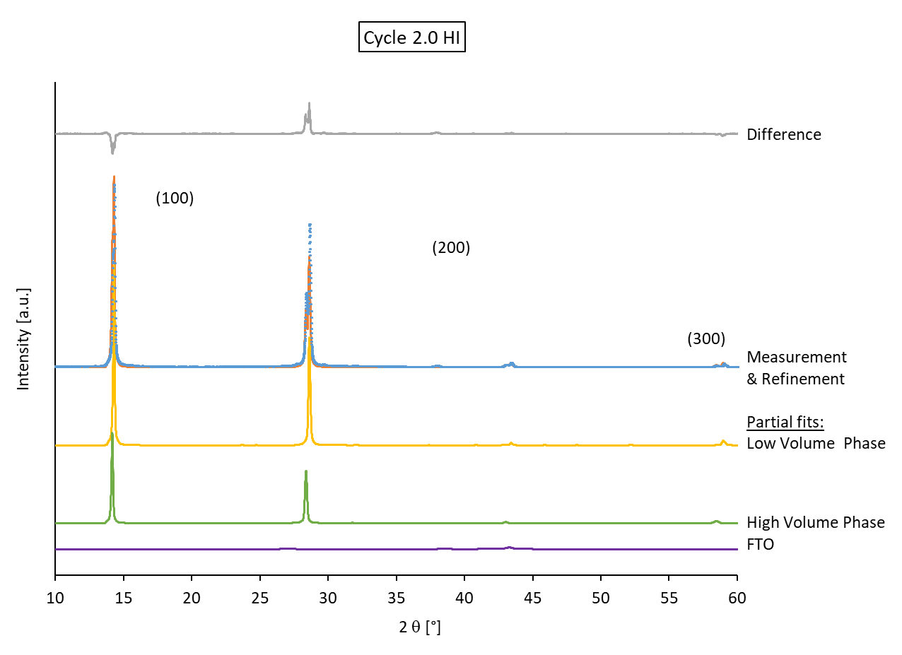
Suppl. Figure 7 XRD pattern and refinements of the 2.0 HI substrate from the CVD process

REFERENCES
26. Kim KS, Oleary TJ, Winograd N. X‐ray photoelectron spectra of lead oxides. Anal Chem. 1973;45(13):2214‐2218.
27. Huang WX, Manser JS, Kamat PV, Ptasinska S. Evolution of chemical composition, morphology, and photovoltaic efficiency of CH(3)NH(3)Pbl(3) perovskite under ambient conditions. Chem Mater. 2016;28(1):303‐311.
28. Hawash Z, Raga SR, Son DY, Ono LK, Park NG, Qi YB. Interfacial modification of perovskite solar cells using an ultrathin MAI layer leads to enhanced energy level alignment, efficiencies, and reproducibility. J Phys Chem Lett. 2017;8(17):3947‐3953.
29. Conings B, Drijkoningen J, Gauquelin N, et al. Intrinsic thermal instability of methylammonium lead trihalide perovskite. Adv Energy Mater. 2015;5(15):1500477.
30. Jiang Y, Juarez‐Perez EJ, Ge QQ, et al. Post‐annealing of MAPbI(3) perovskite films with methylamine for efficient perovskite solar cells. Mater Horiz. 2016;3(6):548‐555.
31. Hegde RI, Sainkar SR, Badrinarayanan S, Sinha APB. A study of dilute tin alloys by X‐ray photoelectron‐spectroscopy. J Electron Spectrosc. 1981;24(1):19‐25.

