**Loss of the psychiatric risk factor SLC6A15 is associated with increased metabolic functions in primary hippocampal neurons**

Schraut KG, Kalnytska O, Lamp D, Jastroch M, Eder M, Hausch F, Gassen NC, Moore S, Nagaraj N, Lopez JP, Chen A, Schmidt MV

**Supplemental Figures**

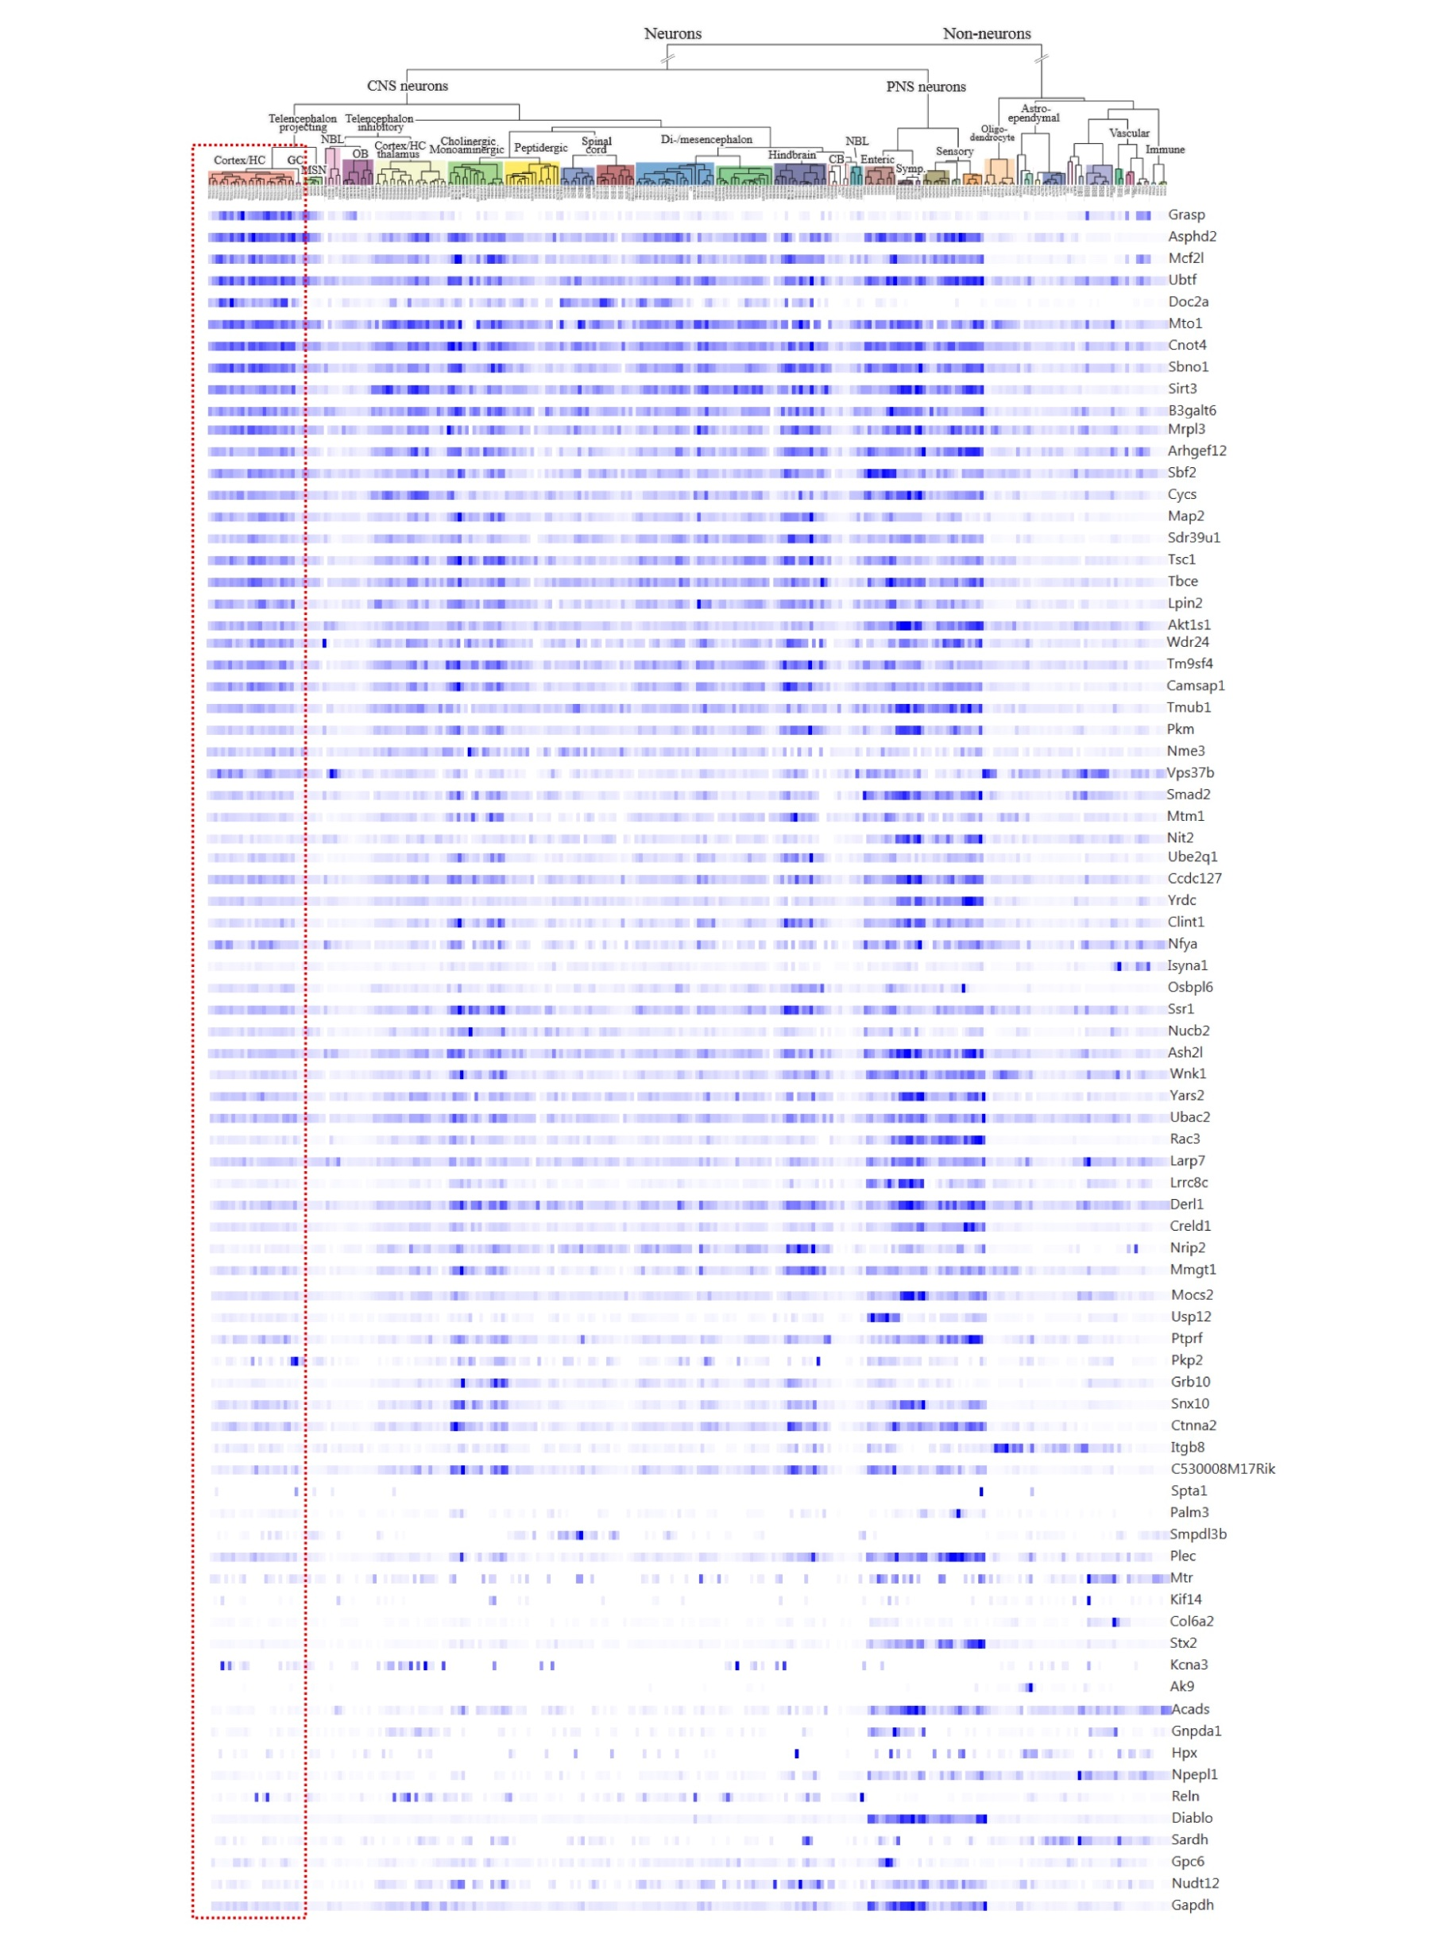

**Supplemental figure 1:** Expression strength of the 81 differentially expressed proteins from the proteomics analysis in the scRNAseq data set. The majority of the corresponding mRNA transcripts are highly expressed in the mouse hippocampus.



**Supplemental figure 2:** Oxygen consumption rate curve for *Slc6a15*-KO and WT primary hippocampal neurons.