Supplementary Materials
Silicon Oxycarbide-Graphite Electrodes for High-Power Energy Storage Devices
Dominik Knozowski ¹, Magdalena Graczyk-Zajac ², Grzegorz Trykowski ³ and
Monika Wilamowska-Zawłocka ^{1,}*
¹ Department of Energy Conversion and Storage, Faculty of Chemistry, Gdańsk University of Technology, Narutowicza 11/12, 80-233 Gdańsk, Poland; dominik.knozowski@pg.edu.pl
² Fachbereich Material und Geowissenschaften, Technische Universität Darmstadt, Otto-Berndt-Straße 3, 64287 Darmstadt, Germany; graczyk@materials.tu-darmstadt.de
³ Faculty of Chemistry, Nicolaus Copernicus University in Torun, 87-100 Torun, Poland; tryki@umk.pl
* Correspondence: monika.wilamowska@pg.edu.pl; Tel.: +48-58-347-24-74
Received: 01 September 2020; Accepted: 23 September 2020; Published: date

(a) | (b)
Figure S1. XPS Si2p spectra of (a) SiOC_{PhTES} and (b) SiOC_{PhTES}/C10g samples.
(a) | (b)
Figure S2. XPS C1s spectra of (a) SiOC_{PhTES} and (b) SiOC_{PhTES}/C10g samples.
.

(a) | (b)
Figure S3. (a) Deconvolution of Raman spectra of the pure graphite, (b) second-order Raman spectra of graphite, ceramic and SiOC/graphite composites.
Table S1. Data obtained from the deconvolution of Raman spectra.
Material | D4 |  |  | D1 |  |  | D3 |  |  | G |  |  | D2
 | cm⁻¹ | Area int. % | FWHM | cm⁻¹ | Area int. % | FWHM | cm⁻¹ | Area int. % | FWHM | cm⁻¹ | Area int. % | FWHM | cm⁻¹ | Area int. % | FWHM
SiOC_{PhTES} | 1194 | 7.07 | 213.73 | 1333 | 65.82 | 164.19 | 1525 | 7.61 | 114.24 | 1575 | 8.34 | 52.61 | 1608 | 11.17 | 43.63
SiOC_{PhTES}/C2g | 1193 | 4.04 | 159.73 | 1327 | 66.23 | 155.38 | 1528 | 7.41 | 135.00 | 1580 | 12.39 | 56.85 | 1609 | 9.93 | 35.85
SiOC_{PhTES}/C4g | 1195 | 5.72 | 219.73 | 1332 | 60.78 | 149.48 | 1525 | 7.62 | 143.96 | 1571 | 11.72 | 41.50 | 1603 | 14.16 | 48.20
SiOC_{PhTES}/C10g | 1197 | 6.90 | 188.33 | 1333 | 60.78 | 142.96 | 1528 | 7.97 | 131.37 | 1580 | 13.65 | 37.54 | 1610 | 10.71 | 38.59
Graphite | - | - | - | 1348 | 30.62 | 49.83 | - | - | - | 1573 | 65.24 | 23.46 | 1611 | 4.14 | 31.20

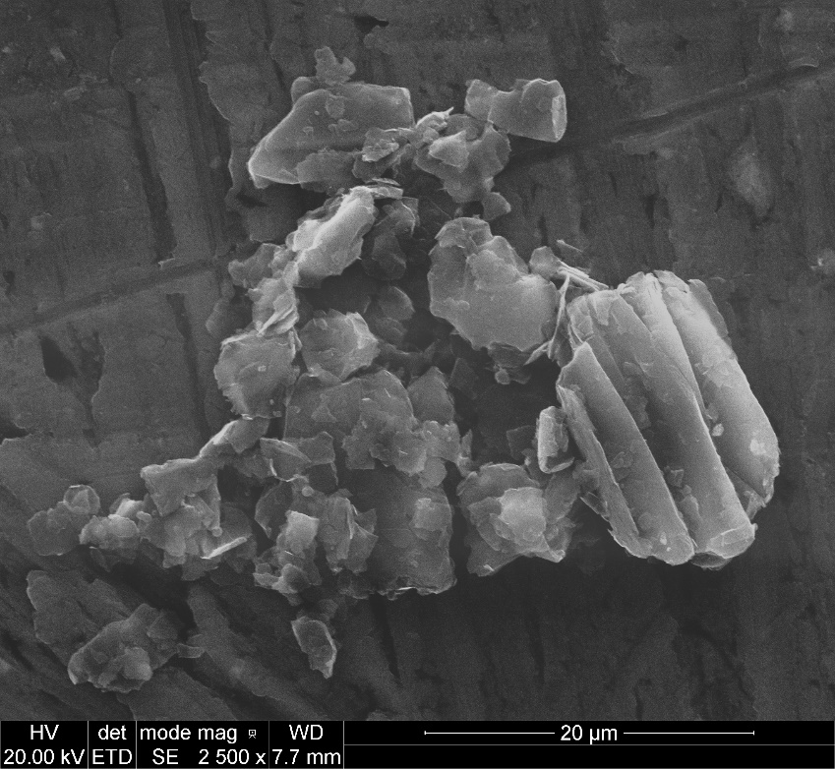  (a) | 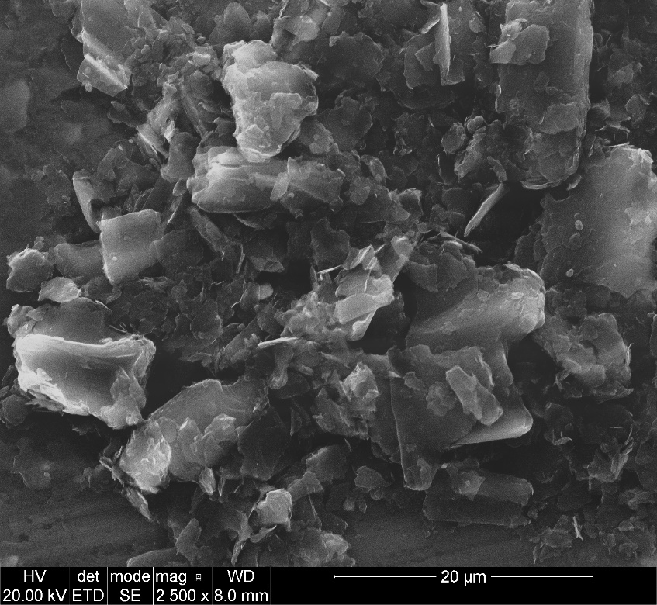  (b)
Figure S4. SEM pictures of (a) graphite flakes, (b) graphite flakes after 2 h of sonication in isopropanol.

