Supplementary material

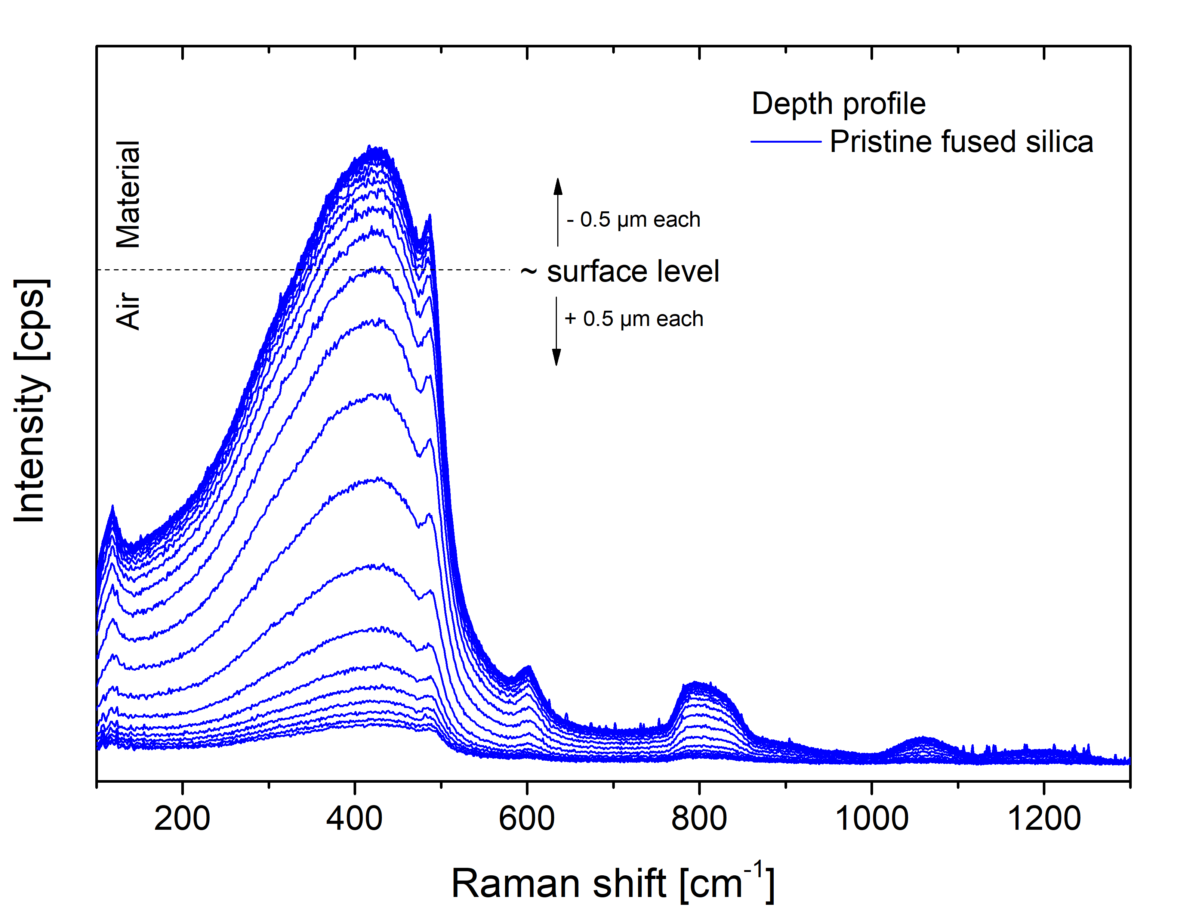
SF 1: Raman spectra from Z-depth profiling on a pristine fused silica surface. The surface level is sketched as dotted line. Higher intensities belong to focal points within the material, lower intensities to focal points in air.

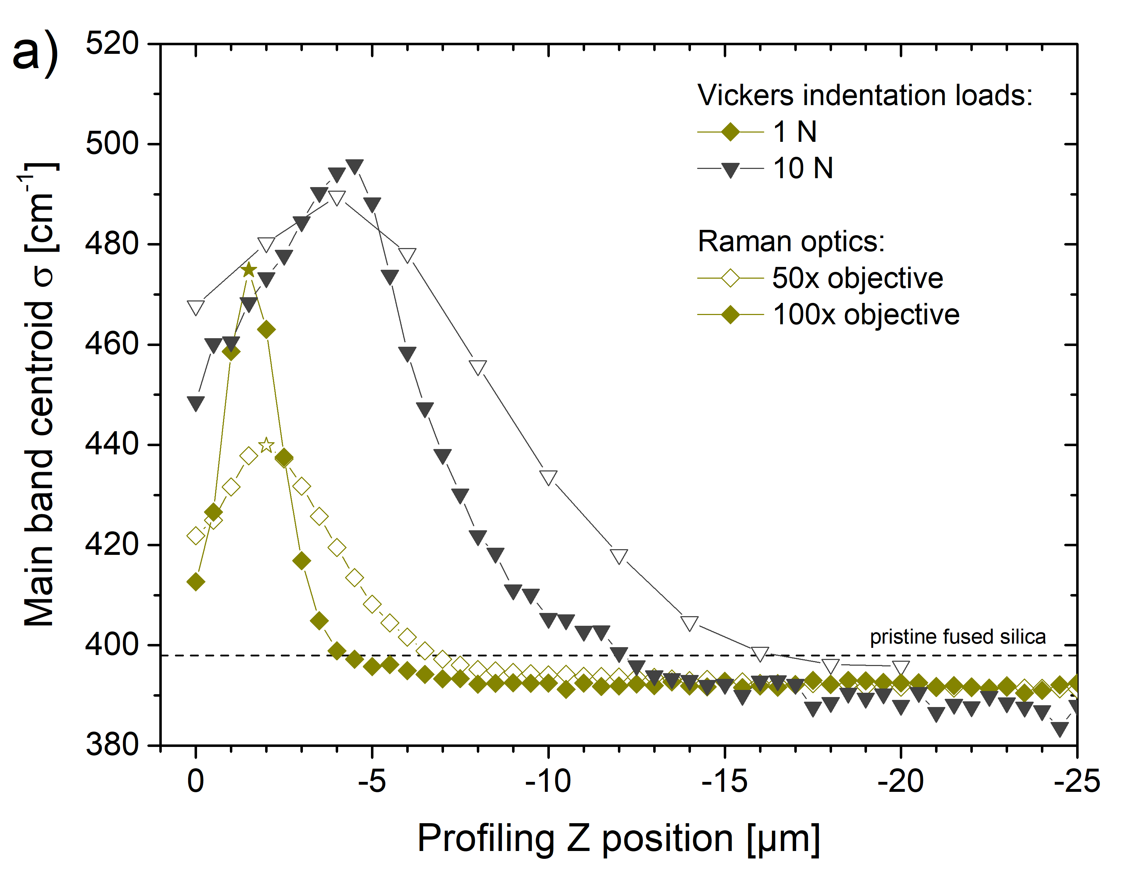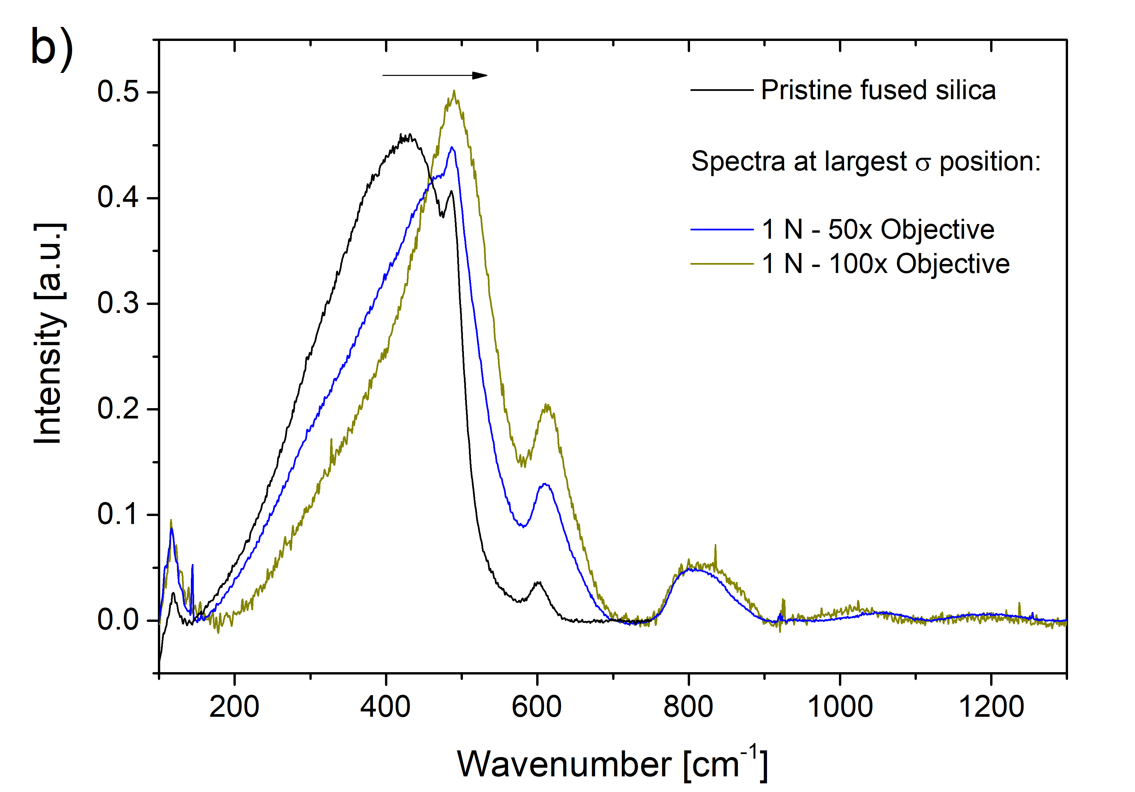
SF 2: a) Raman Z-depth profiles of σ at the center of Vickers indents in fused silica for 1 N and 10 N loading using two different objectives (50x and 100x). Thereby the Raman laser spot size is changed, hence the degree of structural averaging changes. The Raman spectra (baseline corrected and normalized) for the 1 N indentation at peak position (indicated by a star) are shown in b). A reference spectrum from the pristine fused silica surface is shown in black.

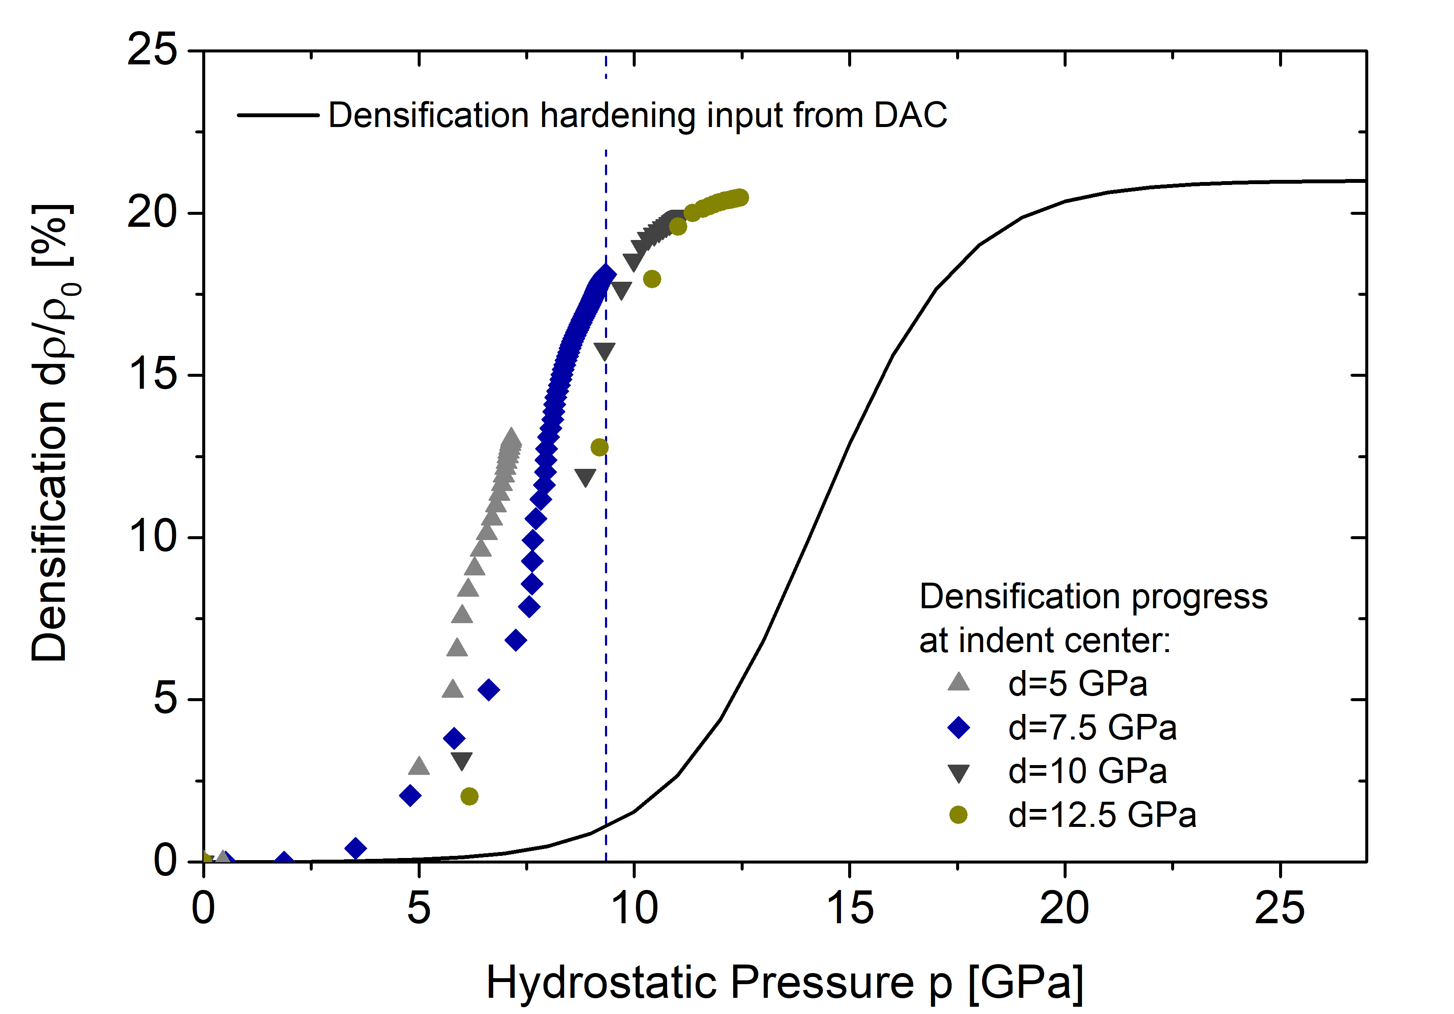
SF 3: The densification state within a single element at indent center as a function of the hydrostatic pressure. The hardness of the material is altered by changing the input for the yield strength under pure shear d. Any input concerning densification is kept constant.

